Title
Smart Attention-Responsive Television (SART)

ABSTRACT
An interactive entertainment device is disclosed, which incorporates a sound sensing system and noise detection hardware for observing surrounding noises. The device can distinguish between various environmental noises and assess whether the viewer is paying attention to the program. It processes the collected sound data and determines when the viewer's attention deviates from the TV program, based on specific sound patterns and volume levels. The device can pause the current program when the system detects that the viewer's attention has shifted away from the screen. It allows for personalization based on the viewer's environment and viewing habits, and ensures user privacy and security by processing sound analysis locally and not recording or storing any audio data.

TECHNICAL FIELD
The Smart Attention-Responsive Television (SART) is a state-of-the-art home entertainment technology that is equipped with a highly sensitive microphone array for monitoring ambient sounds within its environment.

BACKGROUND
Television has been a primary source of entertainment and information for decades. With the advent of digital technology, televisions have evolved from simple broadcast receivers to smart devices capable of streaming content, connecting to the internet, and even interacting with other smart devices. However, one aspect of the television viewing experience that has remained largely unchanged is the passive nature of the interaction. Viewers are required to manually control their viewing experience, such as pausing the program when they need to divert their attention elsewhere. This can lead to missed content and a disrupted viewing experience. Furthermore, the one-size-fits-all approach of traditional televisions does not cater to the individual needs and habits of the viewer. There is a growing demand for a more interactive and personalized television viewing experience.

SUMMARY
In accordance with embodiments, an interactive entertainment device is provided, incorporating a sound sensing system and fitted with noise detection hardware for observing surrounding noises. The device distinguishes between various environmental noises, assesses viewer attention, processes collected sound data, and determines viewer distraction based on specific sound patterns and volume levels. The device pauses the current program when the viewer's attention shifts away, adjusts the sensitivity of the attention-detection system, allows for personalization based on the viewer's environment and viewing habits, and ensures user privacy and security by processing sound analysis locally and not recording or storing any audio data.
In accordance with other embodiments, a method of operating an interactive entertainment device is provided. The method involves handling noise information, identifying user concentration based on noise patterns and loudness levels, and halting content when user focus changes. The noise analysis is conducted in-house, and no sound information is captured or retained. The method further includes distinguishing between various environmental noises, assessing whether the viewer is paying attention to the program, and adjusting the sensitivity of the attention-detection system.

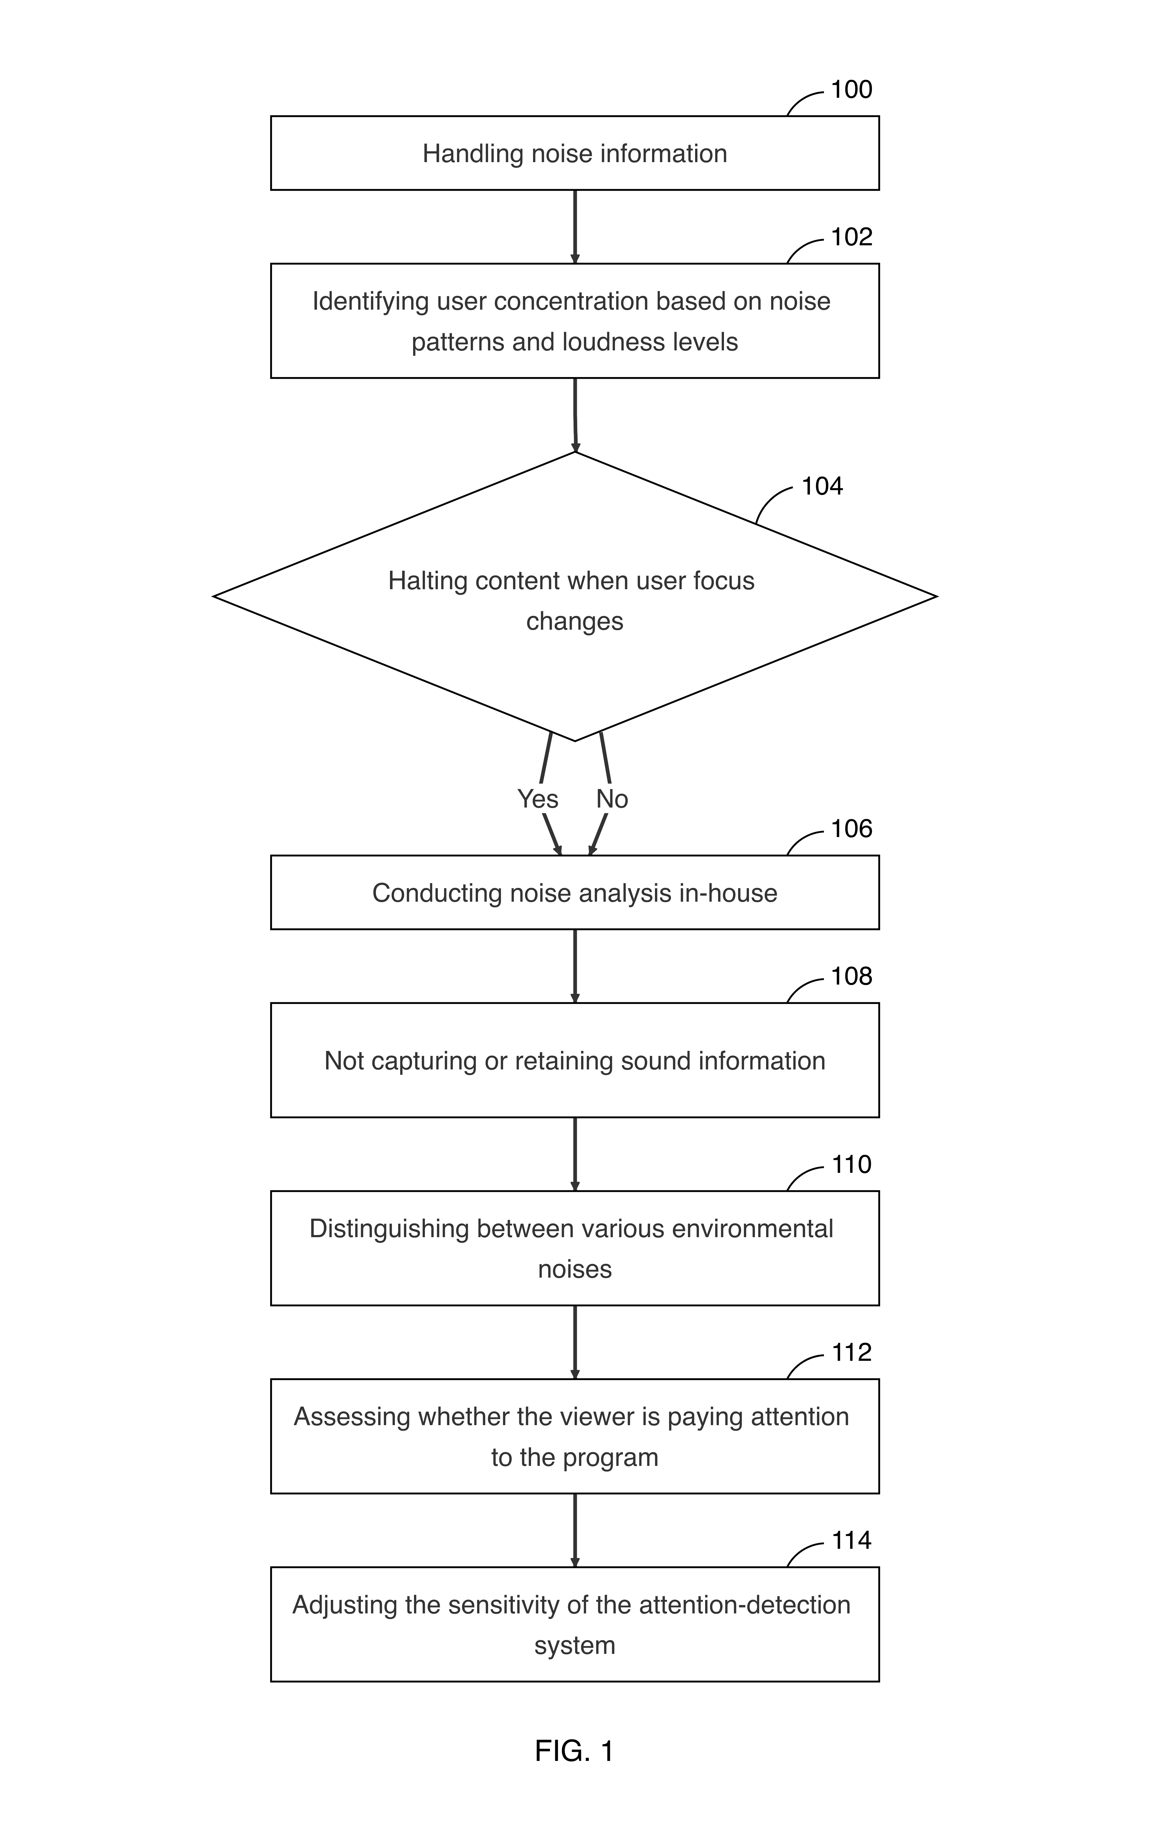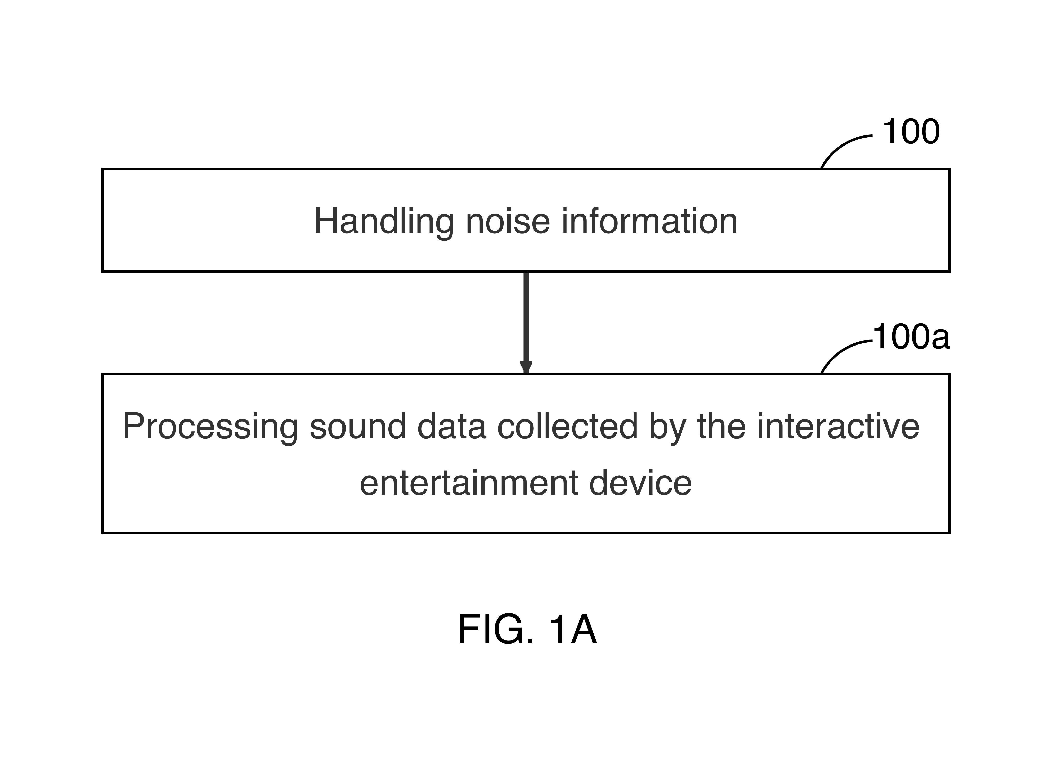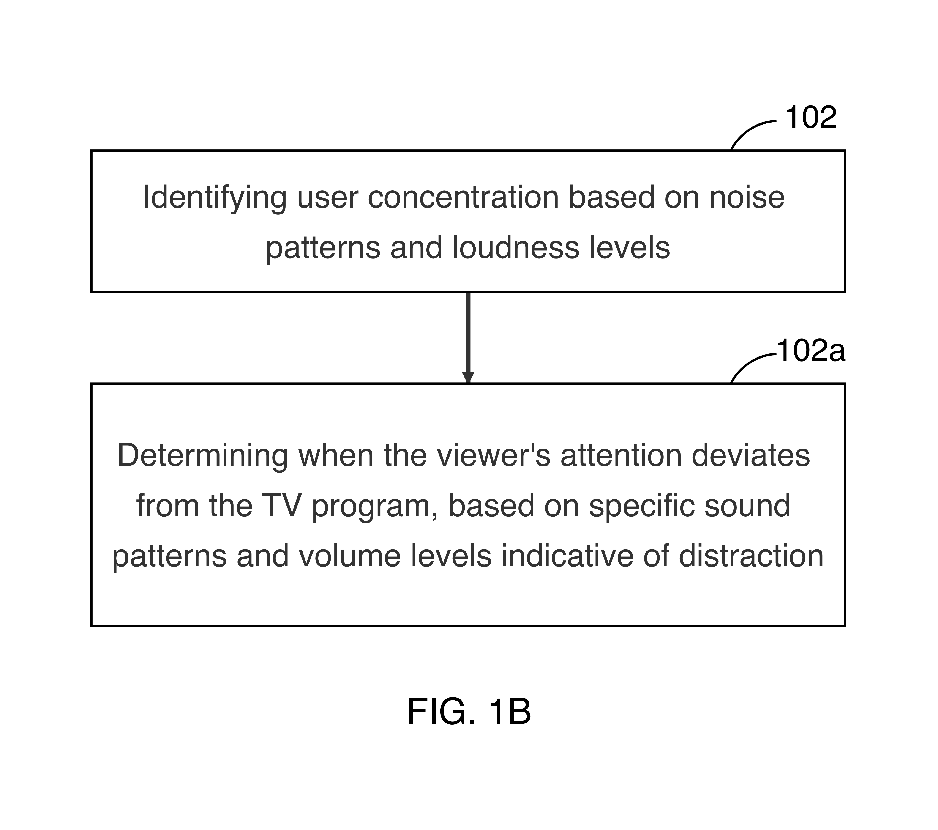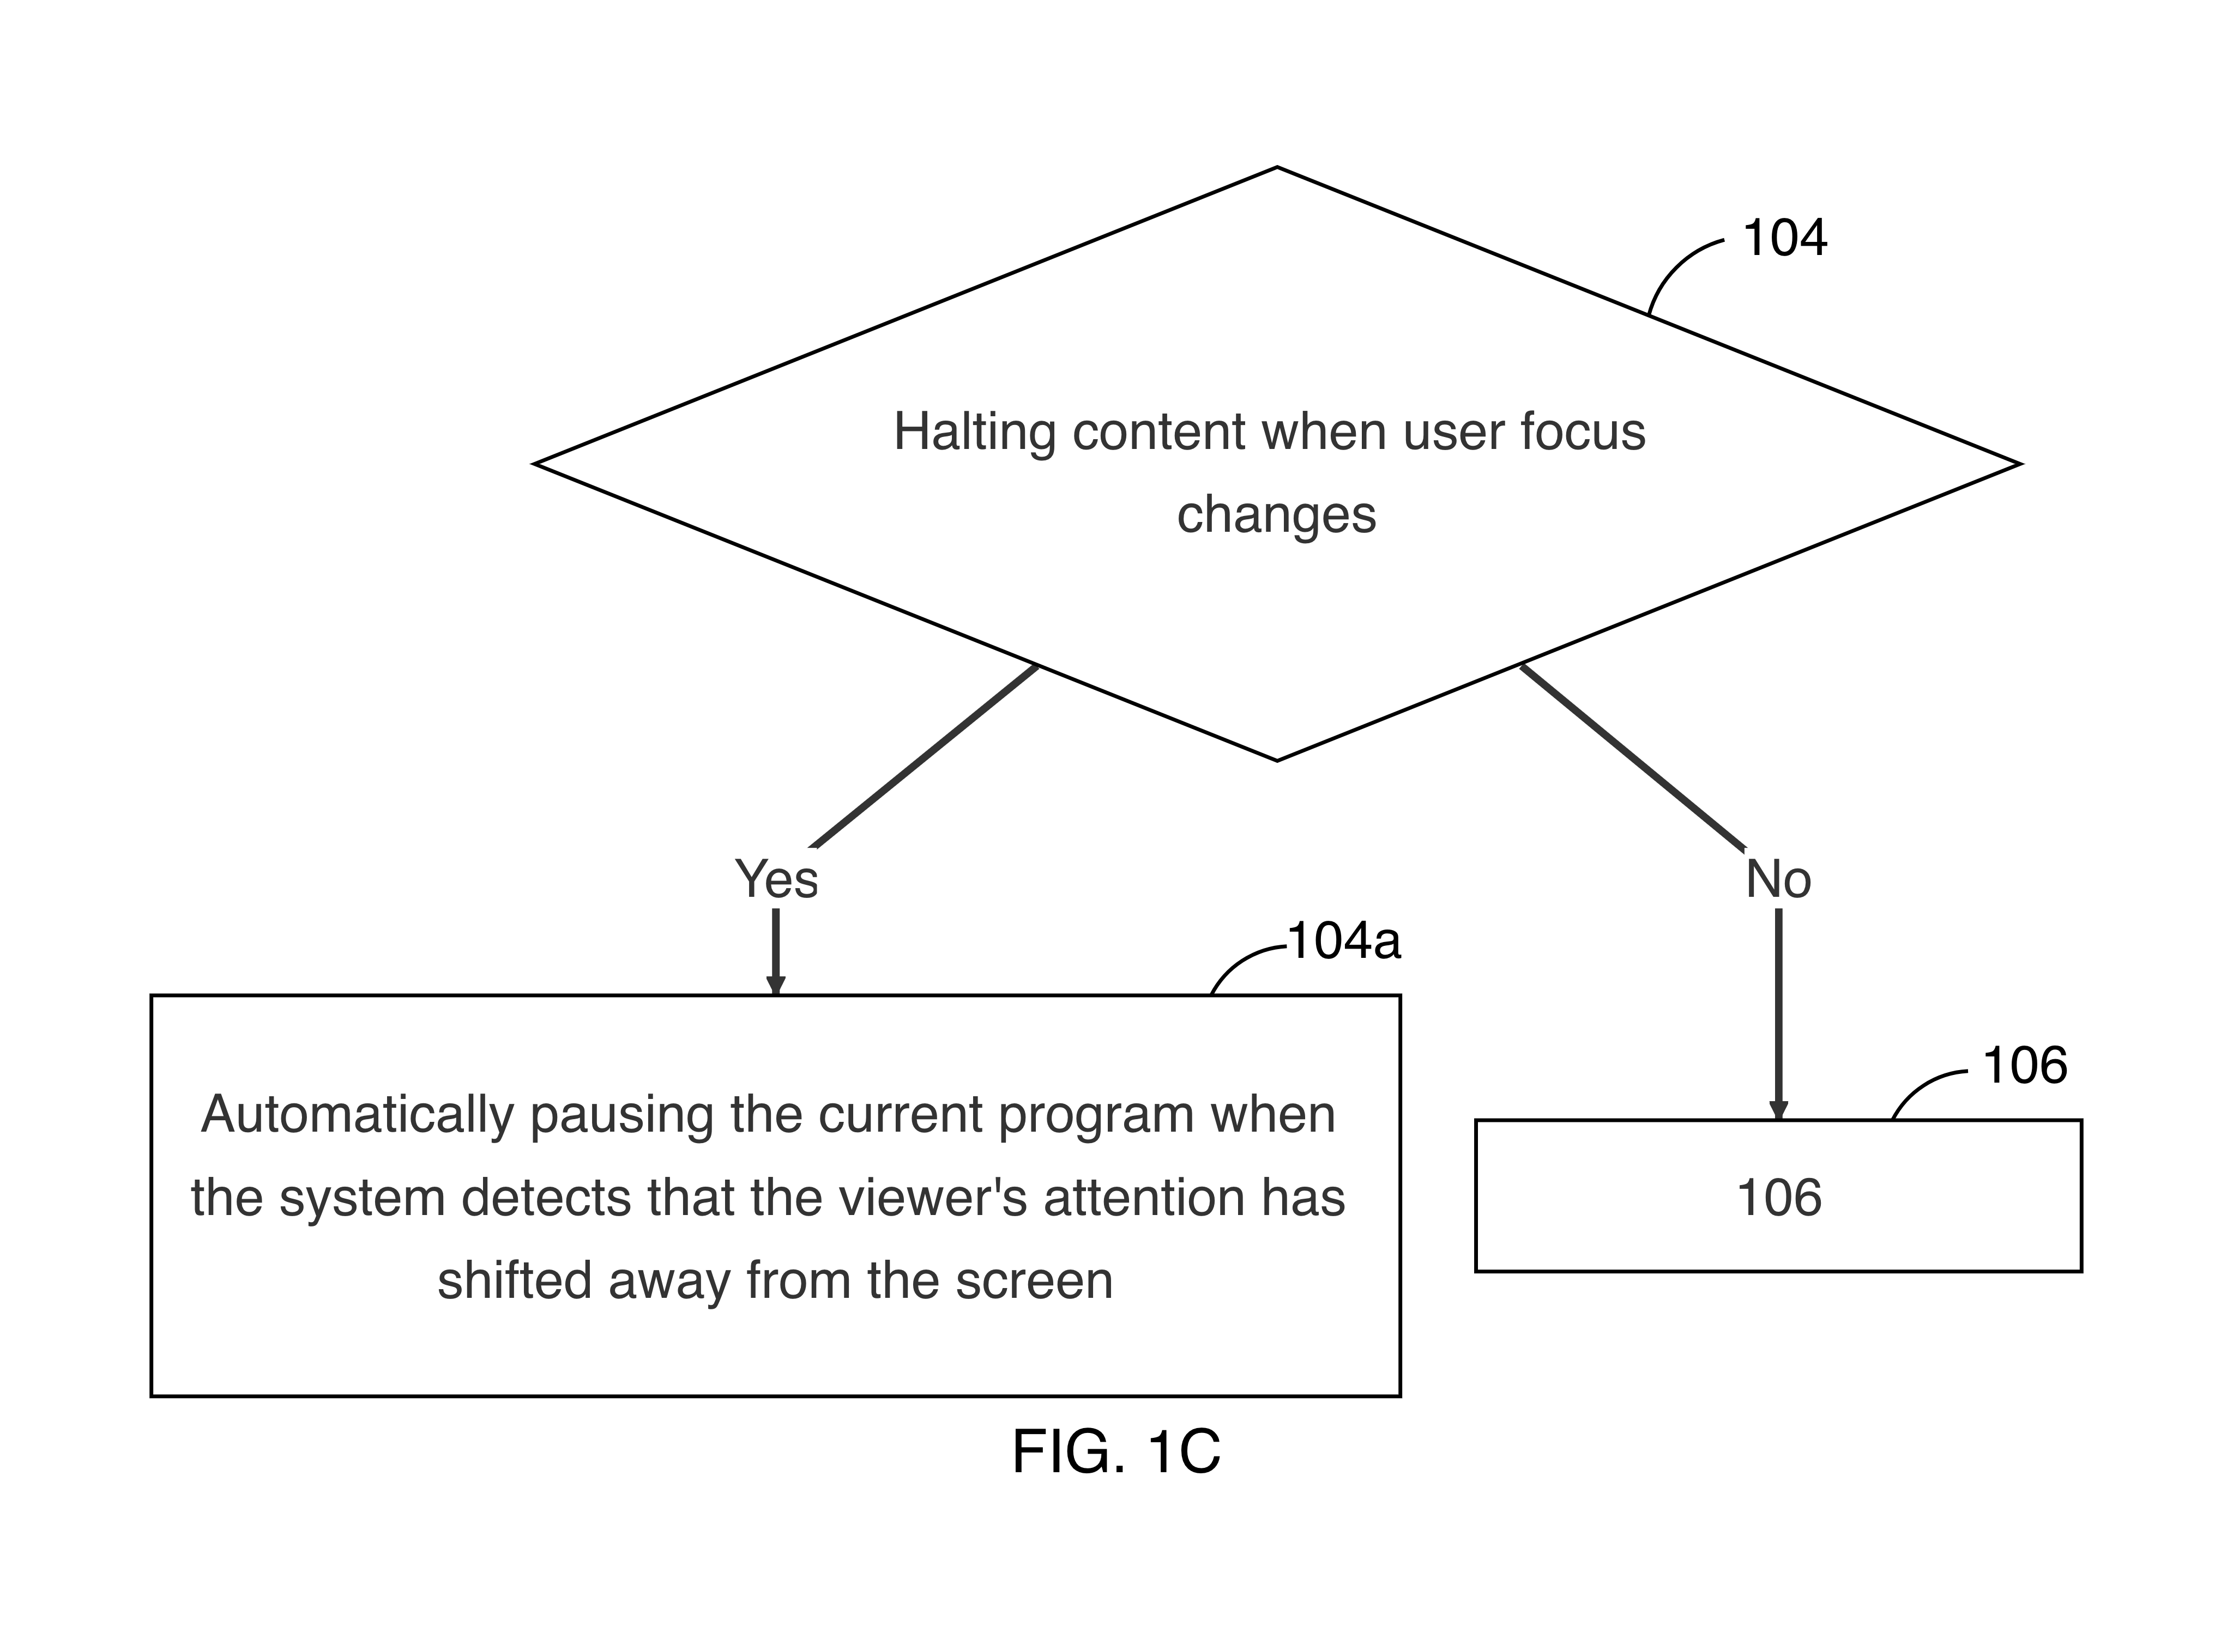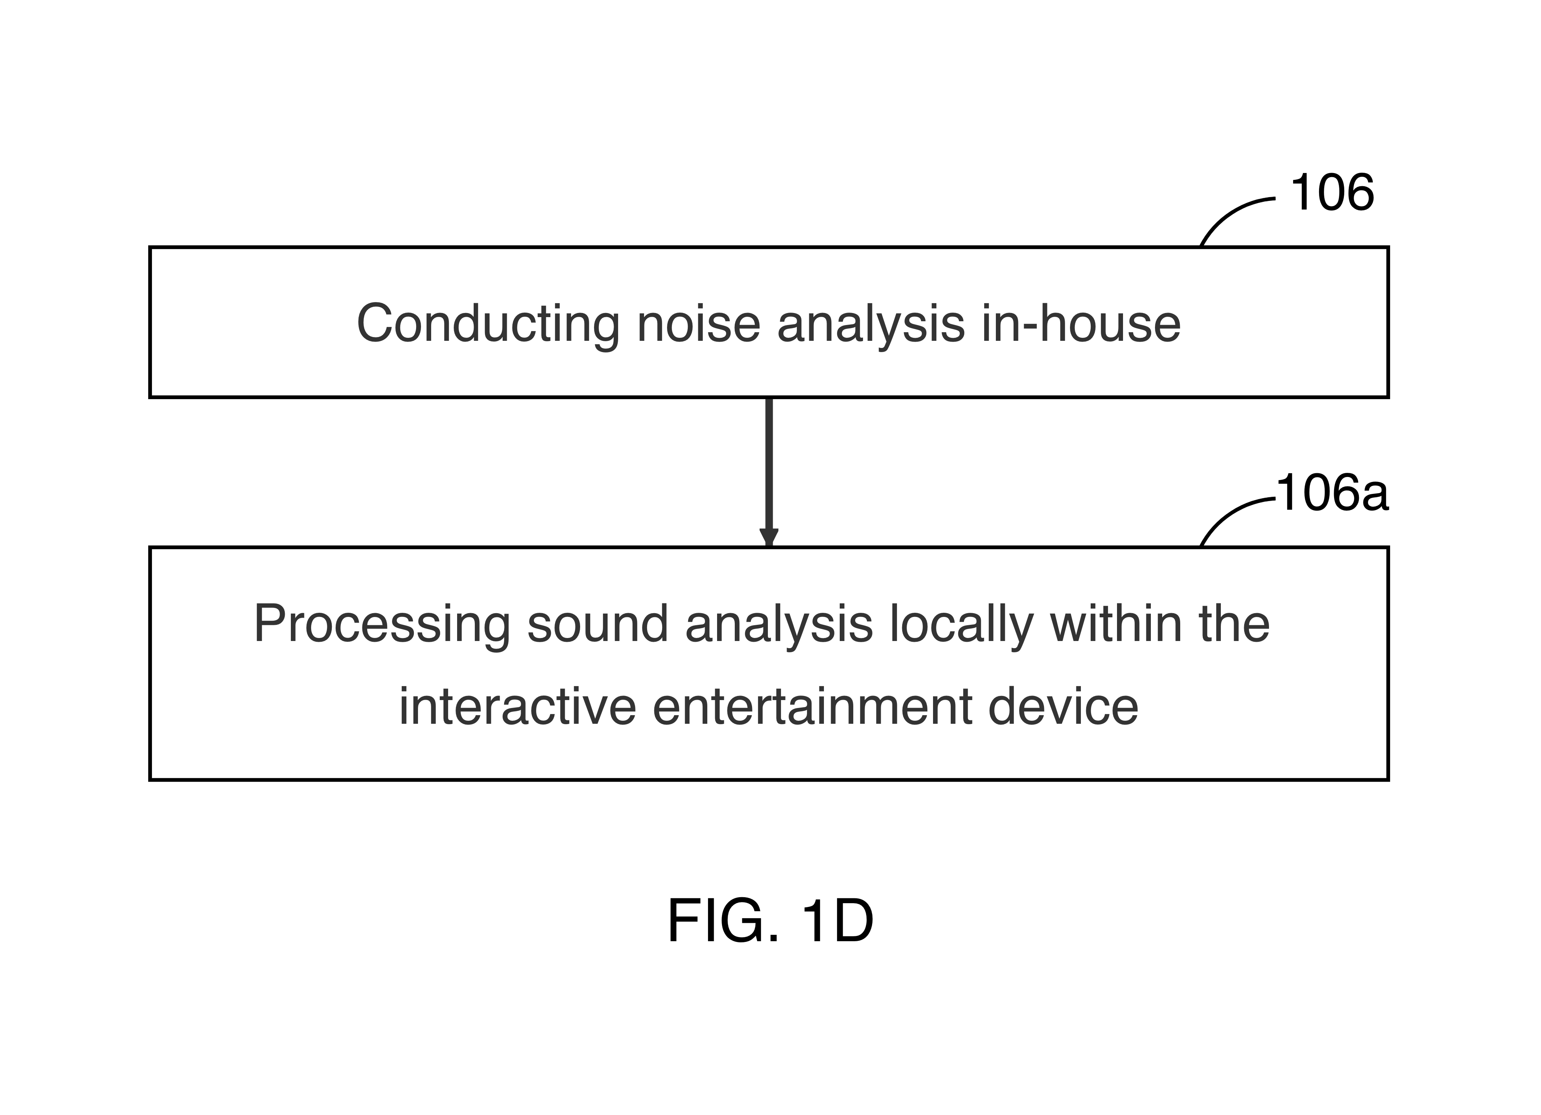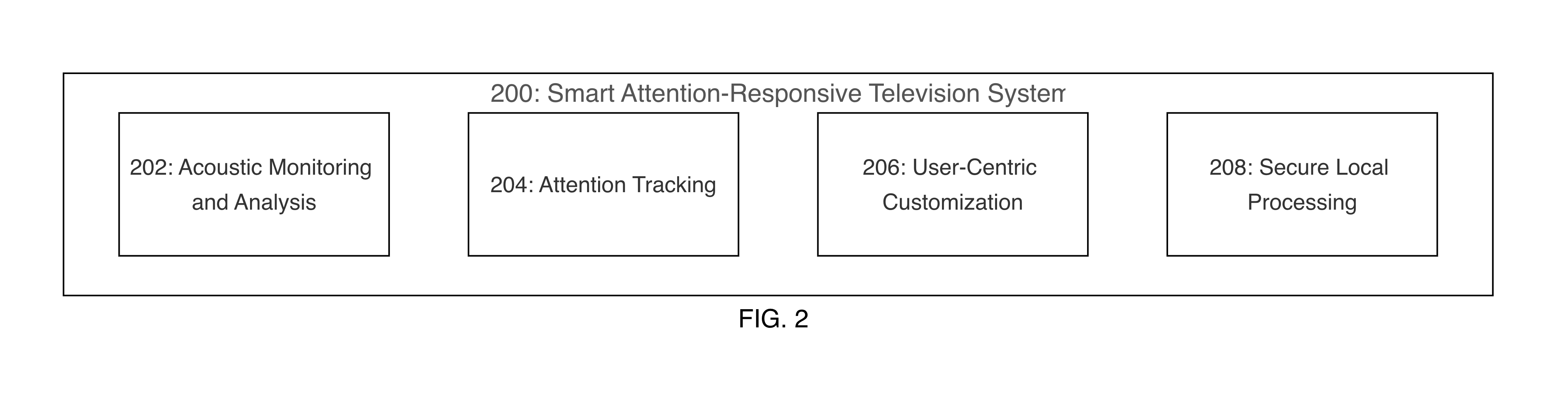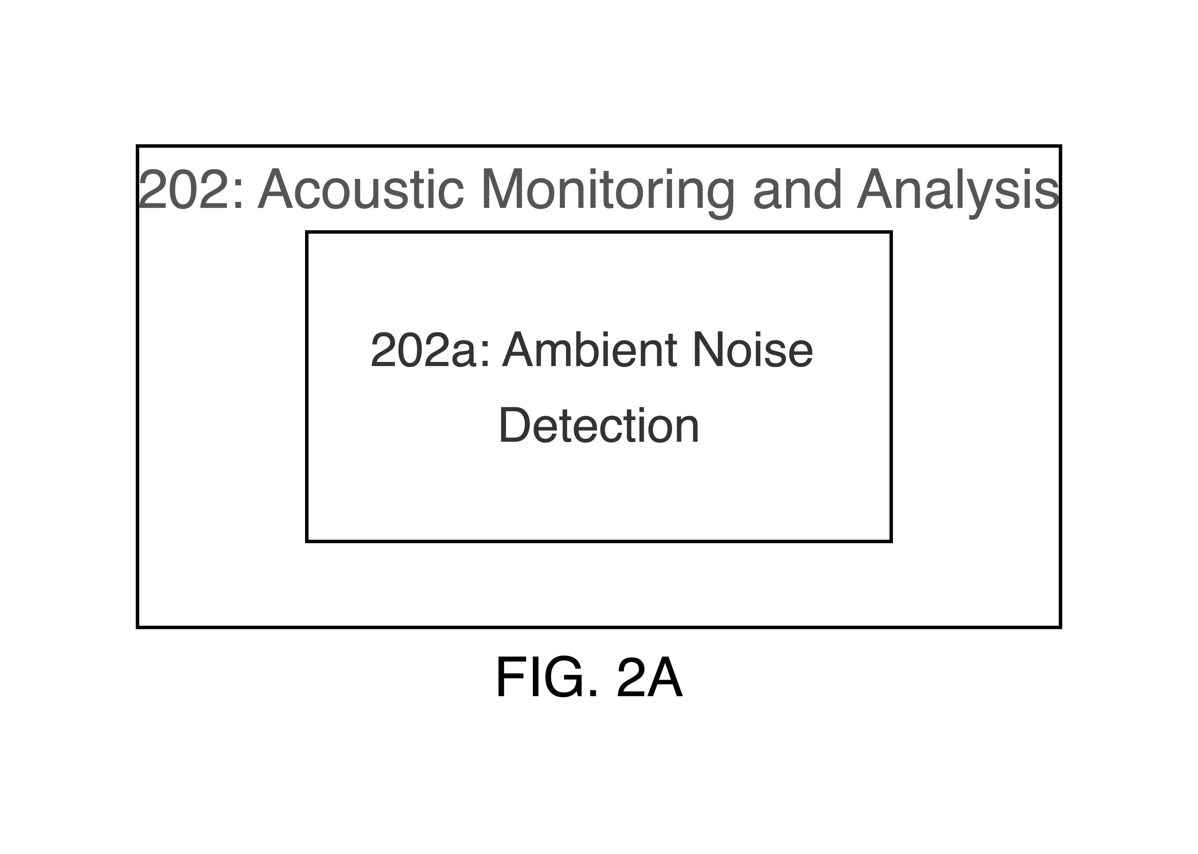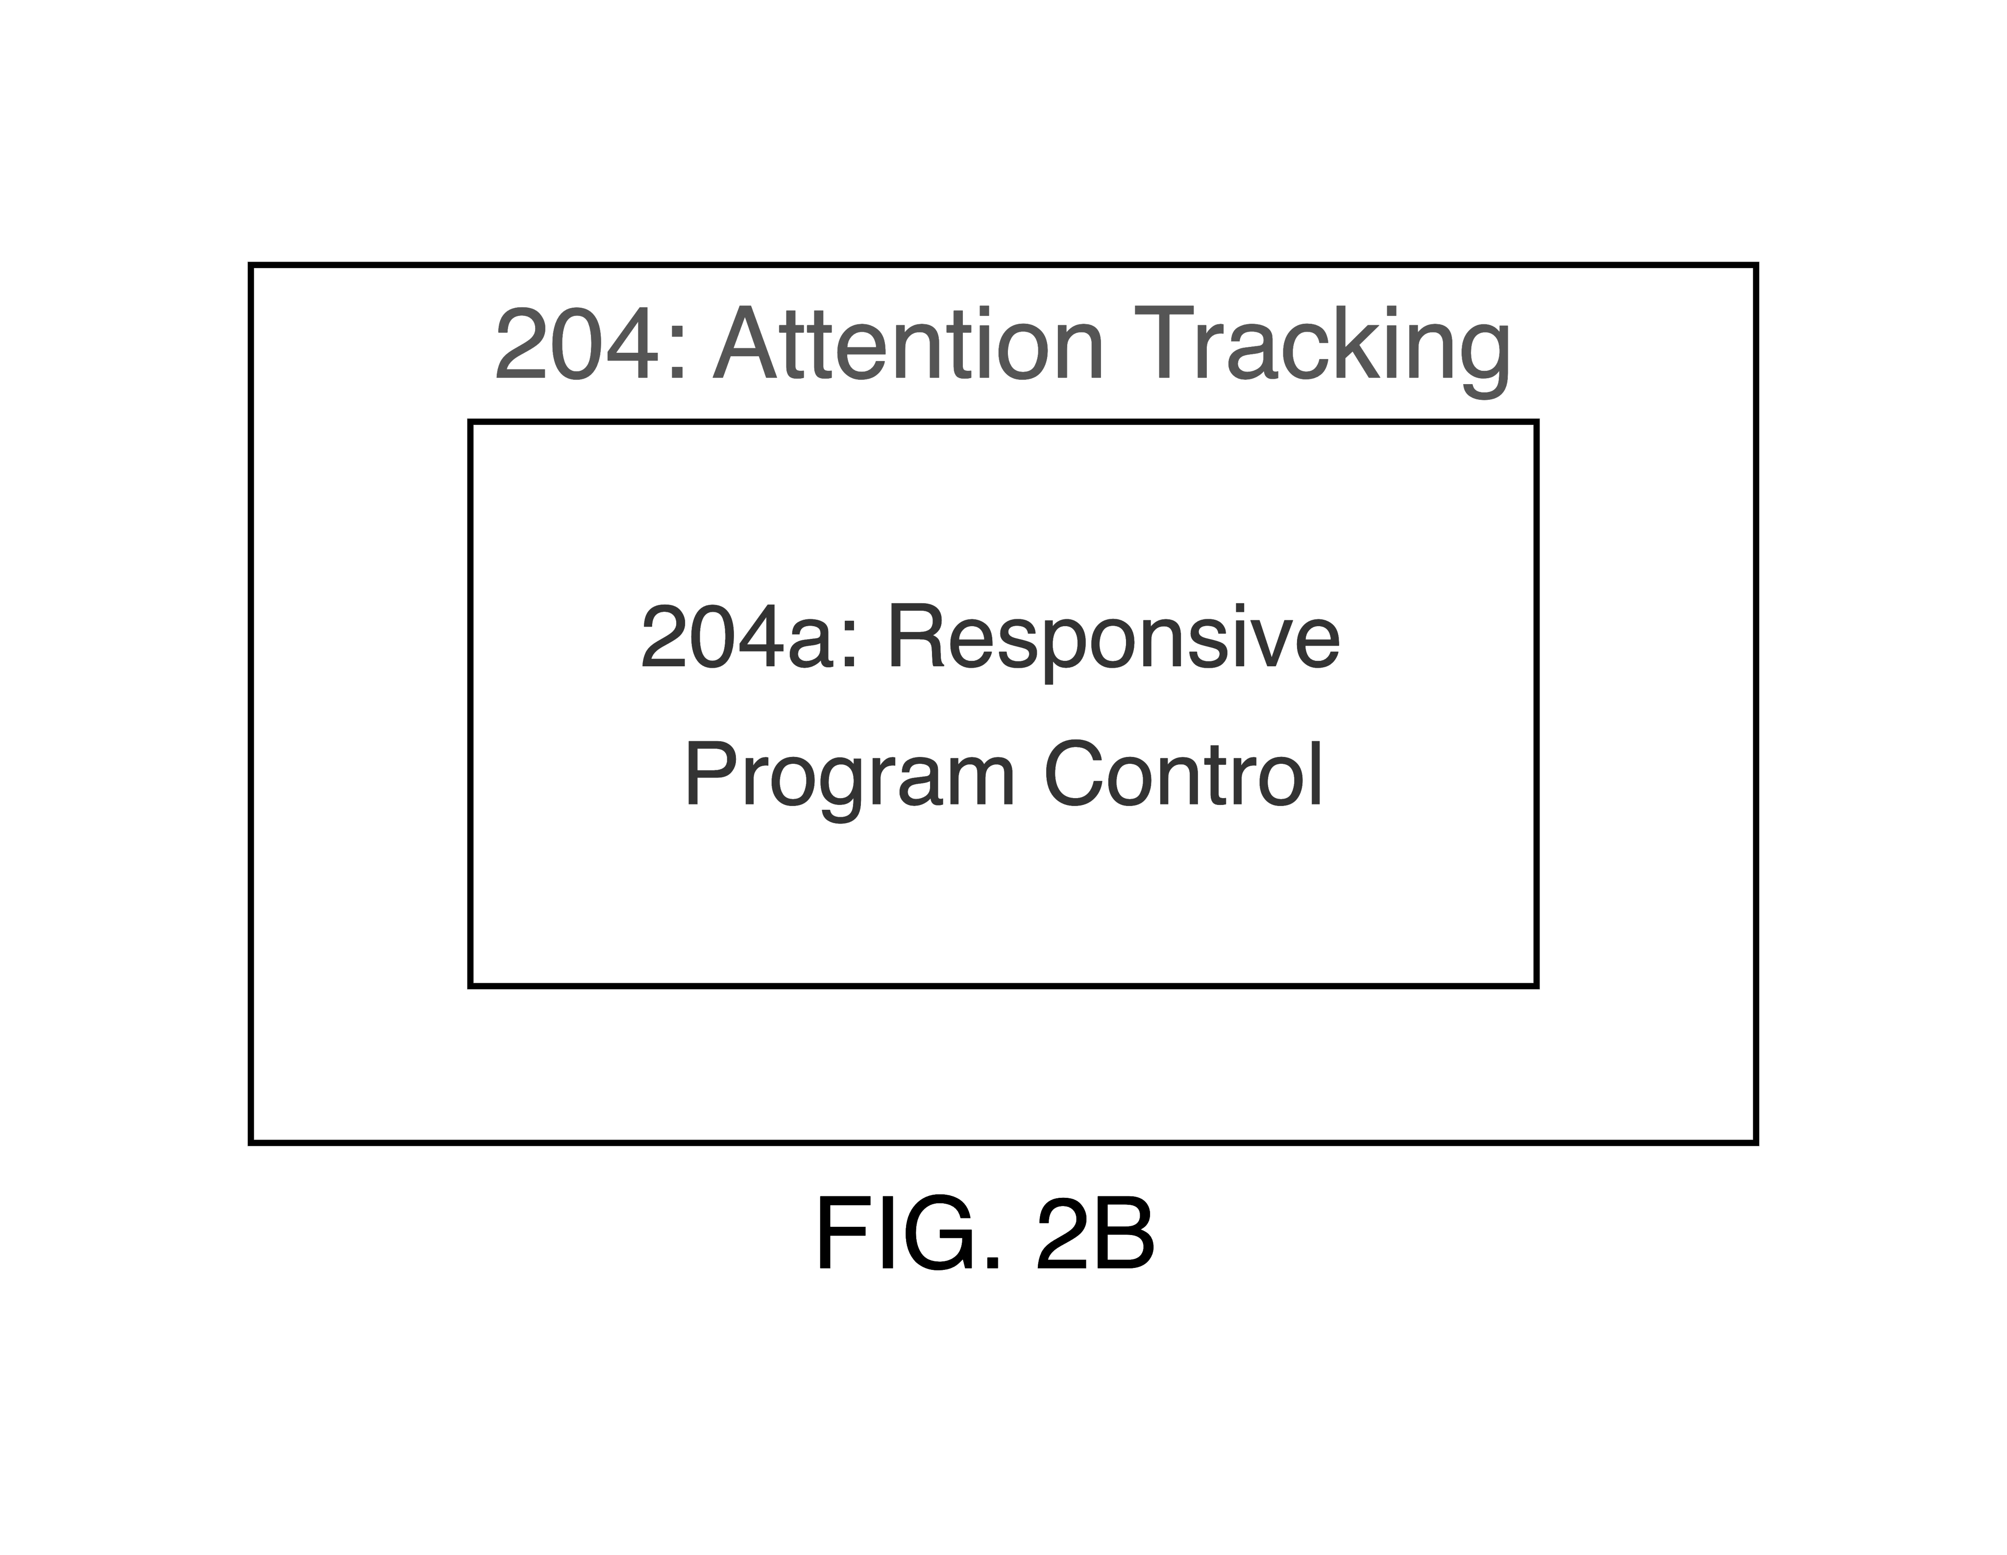
LIST OF FIGURES
FIG. 1 illustrates, in a flowchart, operations for managing content delivery based on user's attention level.
FIG. 1A illustrates, in a flowchart, operations for processing the collected sound data.
FIG. 1B illustrates, in a flowchart, operations for identifying user concentration based on noise patterns and loudness levels.
FIG. 1C illustrates, in a flowchart, operations for halting content when user focus changes.
FIG. 1D illustrates, in a flowchart, operations for conducting noise analysis in-house.
FIG. 2 illustrates, in a block diagram, the components of a Smart Attention-Responsive Television System in accordance with certain embodiments.
FIG. 2A FIG. 2A illustrates, in a block diagram, the 'Acoustic Monitoring and Analysis' component and its sub-component in accordance with certain embodiments.
FIG. 2B FIG. 2B illustrates, in a block diagram, the 'Attention Tracking' component and its sub-component in accordance with certain embodiments.

DETAILED DESCRIPTION
Step 100 involves the Smart Attention-Responsive Television (SART) managing and interpreting sound data collected from its environment. This step is initiated by the device's sound-monitoring system, which includes a microphone array that continuously monitors ambient sounds. The sound data collected by the microphones is then managed by the device, which involves organizing and preparing the data for further analysis.
Sub-step 100-a focuses on the processing of the sound data that has been collected. During this sub-step, the sound data undergoes analysis to identify patterns and volume levels. The processing is conducted by an algorithm within the SART system, which interprets the sound data to assess the level of attention the viewer is giving to the television program.
The microphone array and the algorithm are the primary components involved in steps 100 and 100-a. The microphones serve as the data collection mechanism, capturing sounds within the device's environment. The algorithm serves as the data processor, interpreting the sound data to determine the viewer's engagement with the content being displayed on the screen.
The purpose of steps 100 and 100-a is to enable the SART system to detect when a viewer's attention has shifted away from the television. This detection is based on the analysis of the ambient sound environment. By processing this data, the SART system can respond to changes in viewer attention, such as by pausing the content, to provide a responsive viewing experience.
Step 102 involves the process by which the Smart Attention-Responsive Television (SART) system determines the focus of a viewer based on the analysis of sound patterns and volume levels. The system includes a microphone array that captures ambient sounds within the environment. The collected sound data is then processed by an algorithm designed to interpret these sounds for specific patterns and volume levels that suggest the viewer may be distracted.
Sub-step 102-a delves into the mechanism by which the system pinpoints the moment a viewer's attention shifts away from the television program. The algorithm continuously evaluates the sound data to detect changes that match predefined criteria associated with distraction. When such a match occurs, the system infers that the viewer's focus has shifted.
The process described in step 102 and sub-step 102-a is designed to enhance the viewing experience by pausing the program when it is deduced that the viewer is not actively engaged. This functionality allows viewers to avoid missing content when their attention is diverted. The sensitivity of the system to sound changes can be adjusted, allowing for personalization based on the viewer's environment and habits. This ensures that the television's response is tailored to the individual's needs without storing or recording any sound data, maintaining privacy.
Step 104 involves the television's response to a detected shift in the viewer's focus. This step is characterized by the system's capability to detect when the viewer is no longer engaged with the content on the screen. The components involved include the sound-monitoring system, the algorithm for detecting attention, and the television's playback control mechanism. The sound-monitoring system, which comprises a microphone array, monitors ambient sounds to assess viewer engagement. The algorithm processes the sound data to identify patterns and volume levels that suggest the viewer's attention has shifted from the program. When such a shift is detected, the television's playback control mechanism is activated to halt the content.
Sub-step 104-a defines the functionality that pauses the program automatically when a loss of viewer attention is detected. The playback control mechanism of the television executes the pause command. This action occurs without user input, aiming to provide an uninterrupted viewing experience. The capability to pause content automatically results from the coordination between the sound-monitoring hardware, the algorithm for attention detection, and the playback control mechanism. This coordination allows the television to respond to the viewer's behavior promptly.
During operation, if the viewer is distracted, for example by a phone call or engaging in a conversation, the microphone array detects the change in noise. The algorithm analyzes these sounds and determines that they signal distraction. Subsequently, a signal is sent to the playback control mechanism to pause the content on display. This process is designed to minimize the time between the detection of distraction and the pausing of the content, with the aim of maintaining viewer engagement by ensuring they do not miss the program due to temporary distractions.
The Smart Attention-Responsive Television System (200) is designed to enhance viewer engagement by monitoring and responding to environmental sounds. This system includes the Acoustic Monitoring and Analysis (202), which processes ambient sounds using a microphone array (202-a) to assess viewer attention (204) and control program playback (204-a). Customization (206) and Secure Local Processing (208) ensure tailored experiences and privacy.
Within the Acoustic Monitoring and Analysis (202), the microphone array captures ambient sounds, distinguishing between different types of environmental noises. This capability allows the system to infer whether the viewer is focused on the television program. The captured sounds are processed by an algorithm that operates locally on the device, as part of the Secure Local Processing (208), ensuring that audio data is neither recorded nor stored to maintain user privacy.
The algorithm analyzes sound patterns and volume levels to detect when the viewer's attention shifts away from the television. Upon such detection, the Responsive Program Control sub-component (204-a) pauses the current program to prevent the viewer from missing content. The User-Centric Customization (206) component allows the viewer to adjust the sensitivity of the attention-detection system, providing a personalized viewing experience that adapts to individual habits and environmental conditions.
The Acoustic Monitoring and Analysis component (202) is integral to the Smart Attention-Responsive Television, facilitating sound-based interaction and viewer engagement. This component includes the Ambient Noise Detection sub-component (202-a), which is tasked with capturing and analyzing sound. It distinguishes environmental noises and processes audio data to assess viewer attention.
Component 202 consists of a sound sensing system equipped with a microphone array that monitors ambient sounds. The microphone array's function is to capture auditory information from the environment, which is then analyzed to determine the viewer's engagement with the television content. Sub-component 202-a specifically focuses on differentiating between various environmental sounds, such as conversations or phone rings, which could indicate whether the viewer is paying attention to the program.
The system processes the collected sound data using an algorithm designed to identify patterns and volume levels that suggest the viewer's attention has shifted away from the television program. When such patterns are detected, the system responds by pausing the current program, thereby preventing the viewer from missing significant content. This response is based on the system's interpretation of the processed sound data and its capability to make decisions in real time.
The processing of sound data and subsequent actions are conducted within the device, ensuring that no audio data is recorded or stored. This local processing is implemented to maintain the privacy and security of the user's information while providing an interactive viewing experience.

CLAIMS
1. An interactive entertainment device, comprising:
incorporating a sound sensing system;
fitted with noise detection hardware;
observing surrounding noises.
2. The interactive entertainment device of claim 1, wherein the sound sensing system is an environmental sound-monitoring system.
3. The interactive entertainment device of claim 1, wherein the noise detection hardware is a highly sensitive microphone array.
4. The interactive entertainment device of claim 1, wherein observing surrounding noises includes monitoring ambient sounds within its environment.
5. The interactive entertainment device of claim 1, further comprising distinguishing between various environmental noises.
6. The interactive entertainment device of claim 1, further comprising assessing whether the viewer is paying attention to the program.
7. The interactive entertainment device of claim 1, further comprising processing the collected sound data.
8. The interactive entertainment device of claim 1, further comprising determining when the viewer's attention deviates from the TV program, based on specific sound patterns and volume levels indicative of distraction.
9. The interactive entertainment device of claim 1, further comprising pausing the current program when the system detects that the viewer's attention has shifted away from the screen.
10. The interactive entertainment device of claim 1, further comprising adjusting the sensitivity of the attention-detection system.
11. The interactive entertainment device of claim 1, further comprising allowing for personalization based on the viewer's environment and viewing habits.
12. The interactive entertainment device of claim 1, further comprising ensuring user privacy and security by processing sound analysis locally and not recording or storing any audio data.
13. A method of operating an interactive entertainment device, comprising:
handling noise information;
identifying user concentration based on noise patterns and loudness levels;
halting content when user focus changes;
noise analysis conducted in-house;
no sound information captured or retained.
14. The method of claim 13, wherein handling noise information includes processing sound data collected by the interactive entertainment device.
15. The method of claim 13, wherein identifying user concentration includes determining when the viewer's attention deviates from the TV program, based on specific sound patterns and volume levels indicative of distraction.
16. The method of claim 13, wherein halting content includes automatically pausing the current program when the system detects that the viewer's attention has shifted away from the screen.
17. The method of claim 13, wherein noise analysis conducted in-house includes processing sound analysis locally within the interactive entertainment device.
18. The method of claim 13, further comprising distinguishing between various environmental noises.
19. The method of claim 13, further comprising assessing whether the viewer is paying attention to the program.
20. The method of claim 13, further comprising adjusting the sensitivity of the attention-detection system.

