Title
Mixed Reality System with Head-Mounted Display and Base Station Communication and Related Methods

ABSTRACT
The mixed reality system includes a head-mounted display (HMD) with sensors to gather data about the environment and the user, and a base station to create and display frames with virtual content using the sensor data. The base station processes frames using a method that optimises time by utilising motion vectors. Motion vectors are calculated from motion data recorded by HMD's sensors and by a rendering application on the base station. The data stream contains frame data and motion information, which is utilised by HMD when displaying or combining frames for visualisation.

TECHNICAL FIELD
mixed reality systems

BACKGROUND
Mixed reality systems have been gaining popularity due to their ability to blend the physical and virtual worlds, providing users with immersive experiences. These systems typically include a head-mounted display (HMD) and a base station. The HMD is equipped with sensors that collect information about the user's environment and the user, while the base station is responsible for generating and rendering frames with virtual content based on the sensor data. The frames are then transmitted to the HMD for display. However, the process of encoding, transmitting, and decoding these frames can be time-consuming and may lead to latency issues, which can negatively impact the user's experience. Furthermore, if a frame is not received from the base station, the HMD may not be able to display any content, leaving the user in a state of disconnection from the virtual world. Therefore, there is a need for improvements in the way mixed reality systems handle the encoding, transmission, and decoding of frames, as well as the handling of situations where a frame is not received from the base station.

SUMMARY
In accordance with embodiments, a mixed reality system is provided, comprising a head-mounted display (HMD) with environment-detecting and user-detecting sensors. The HMD is configured to gather data about the environment and the user and send this data to a base station via a connection. The base station is configured to create and display frames with virtual content using the sensor data and process frames using a method that optimises time by utilising motion vectors. The motion vectors are calculated from motion data recorded by the HMD's sensors and by a rendering application on the base station. The system also includes encoders that predict motion vectors using a previous frame. A data stream contains frame data and motion information, which is transmitted to the HMD and utilised by the HMD when displaying or combining frames for visualisation.
In accordance with other embodiments, a method for operating a mixed reality system is provided. The method involves providing a HMD with environment-detecting and user-detecting sensors, and a base station configured to create and display frames with virtual content using the sensor data. The frames are processed by the base station, and motion vectors are calculated from motion data recorded by the HMD's sensors and by a rendering application on the base station. The method also involves predicting motion vectors using a previous frame by encoders, containing frame data and motion information in a data stream, transmitting frame data to the HMD with motion information, and utilising motion information by the HMD when displaying or combining frames for visualisation.

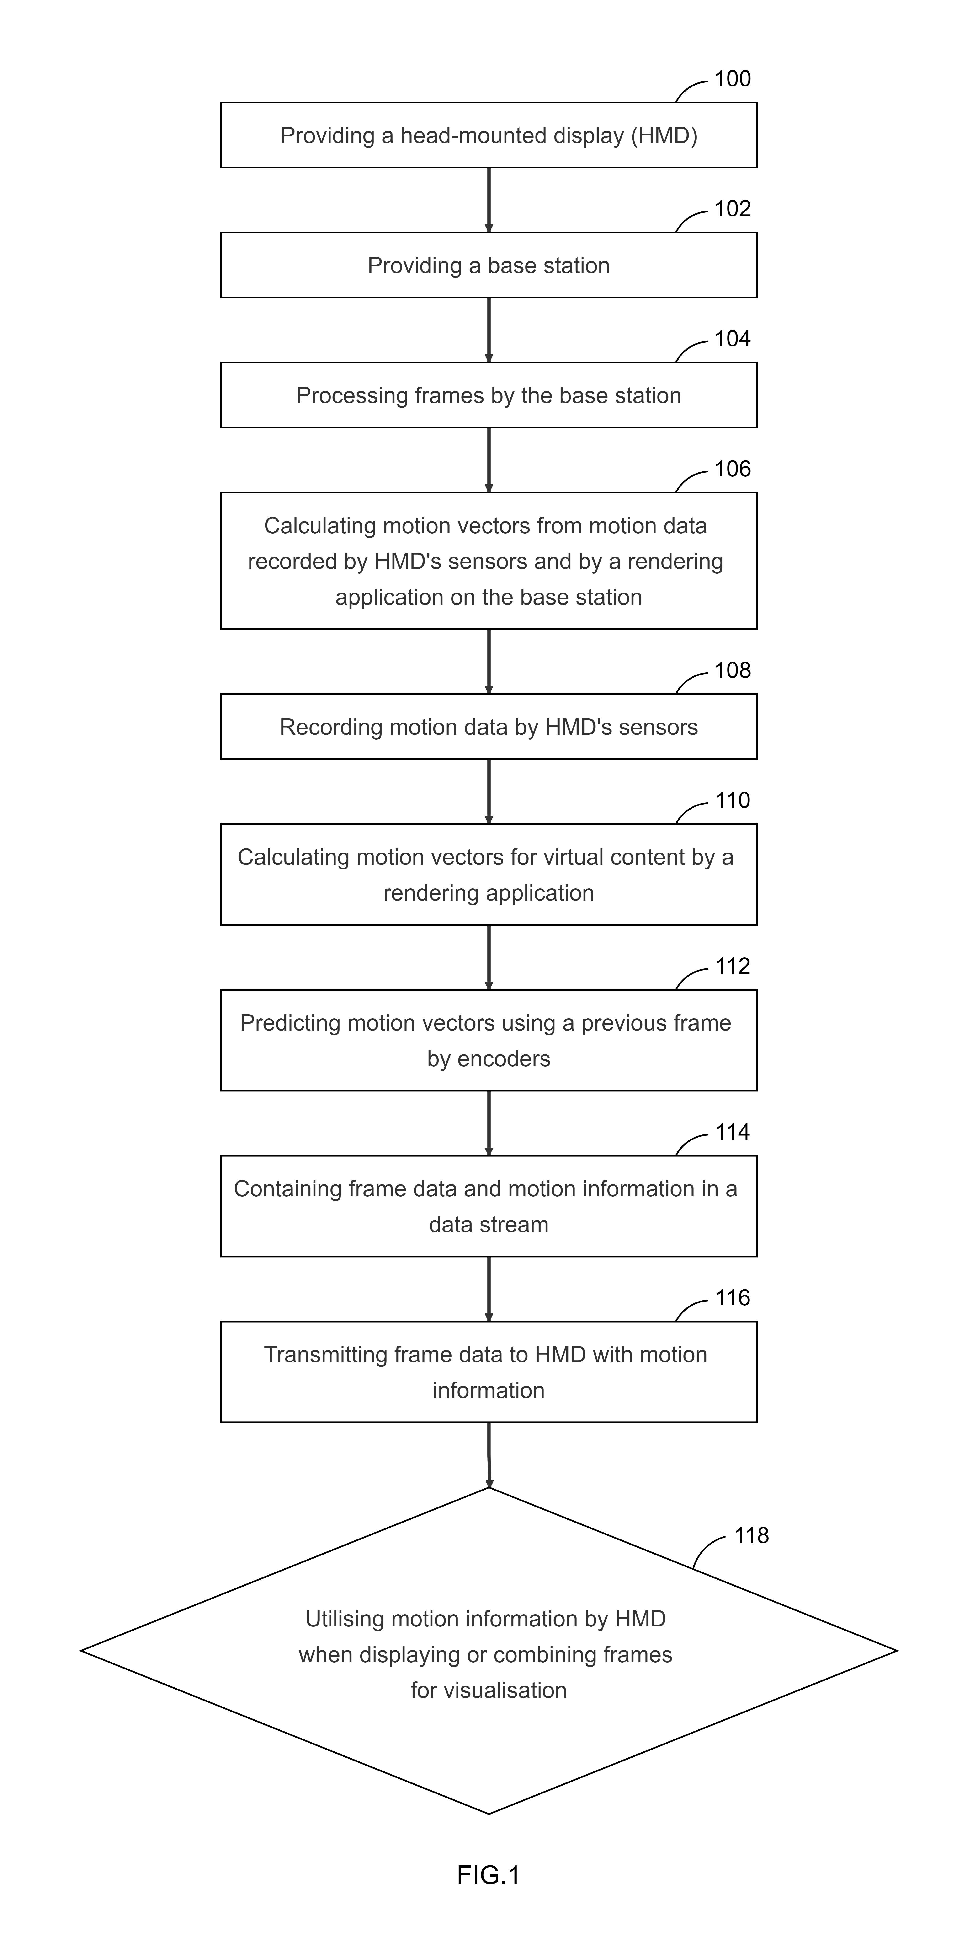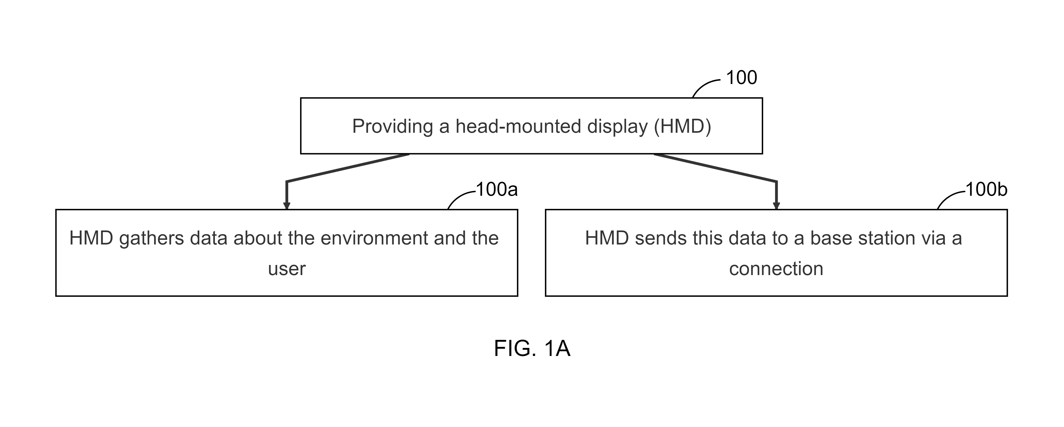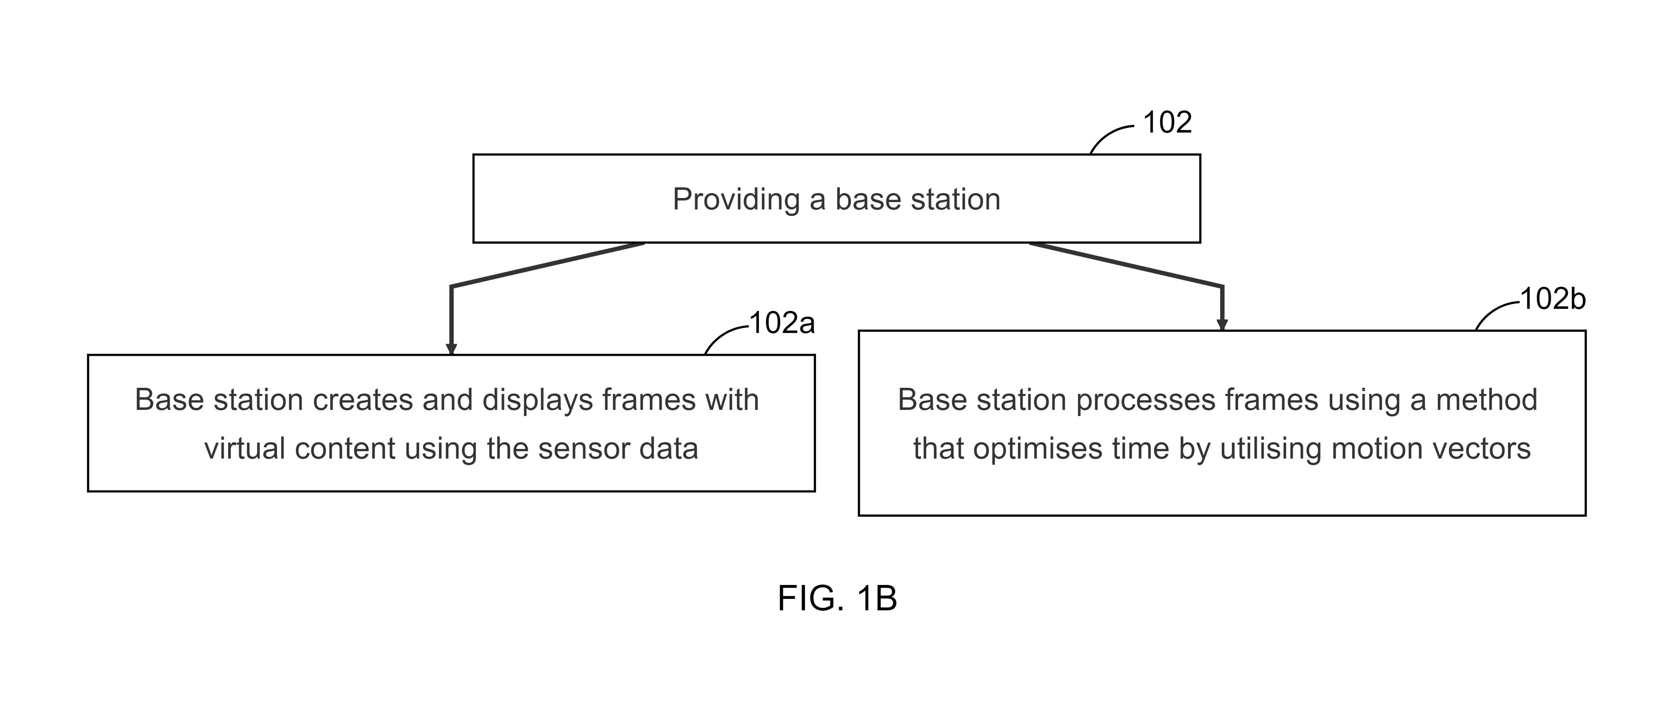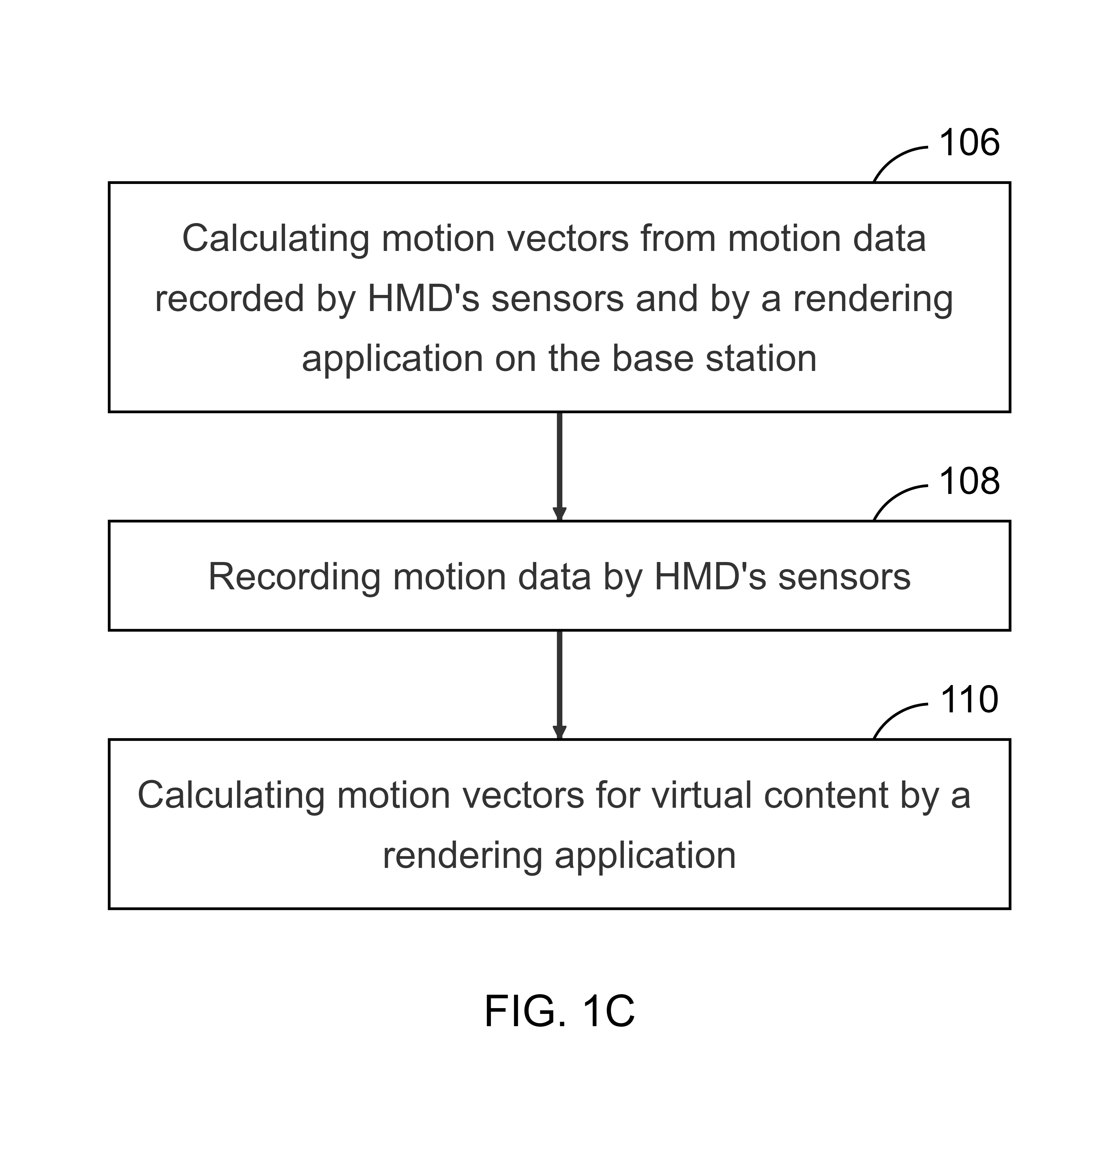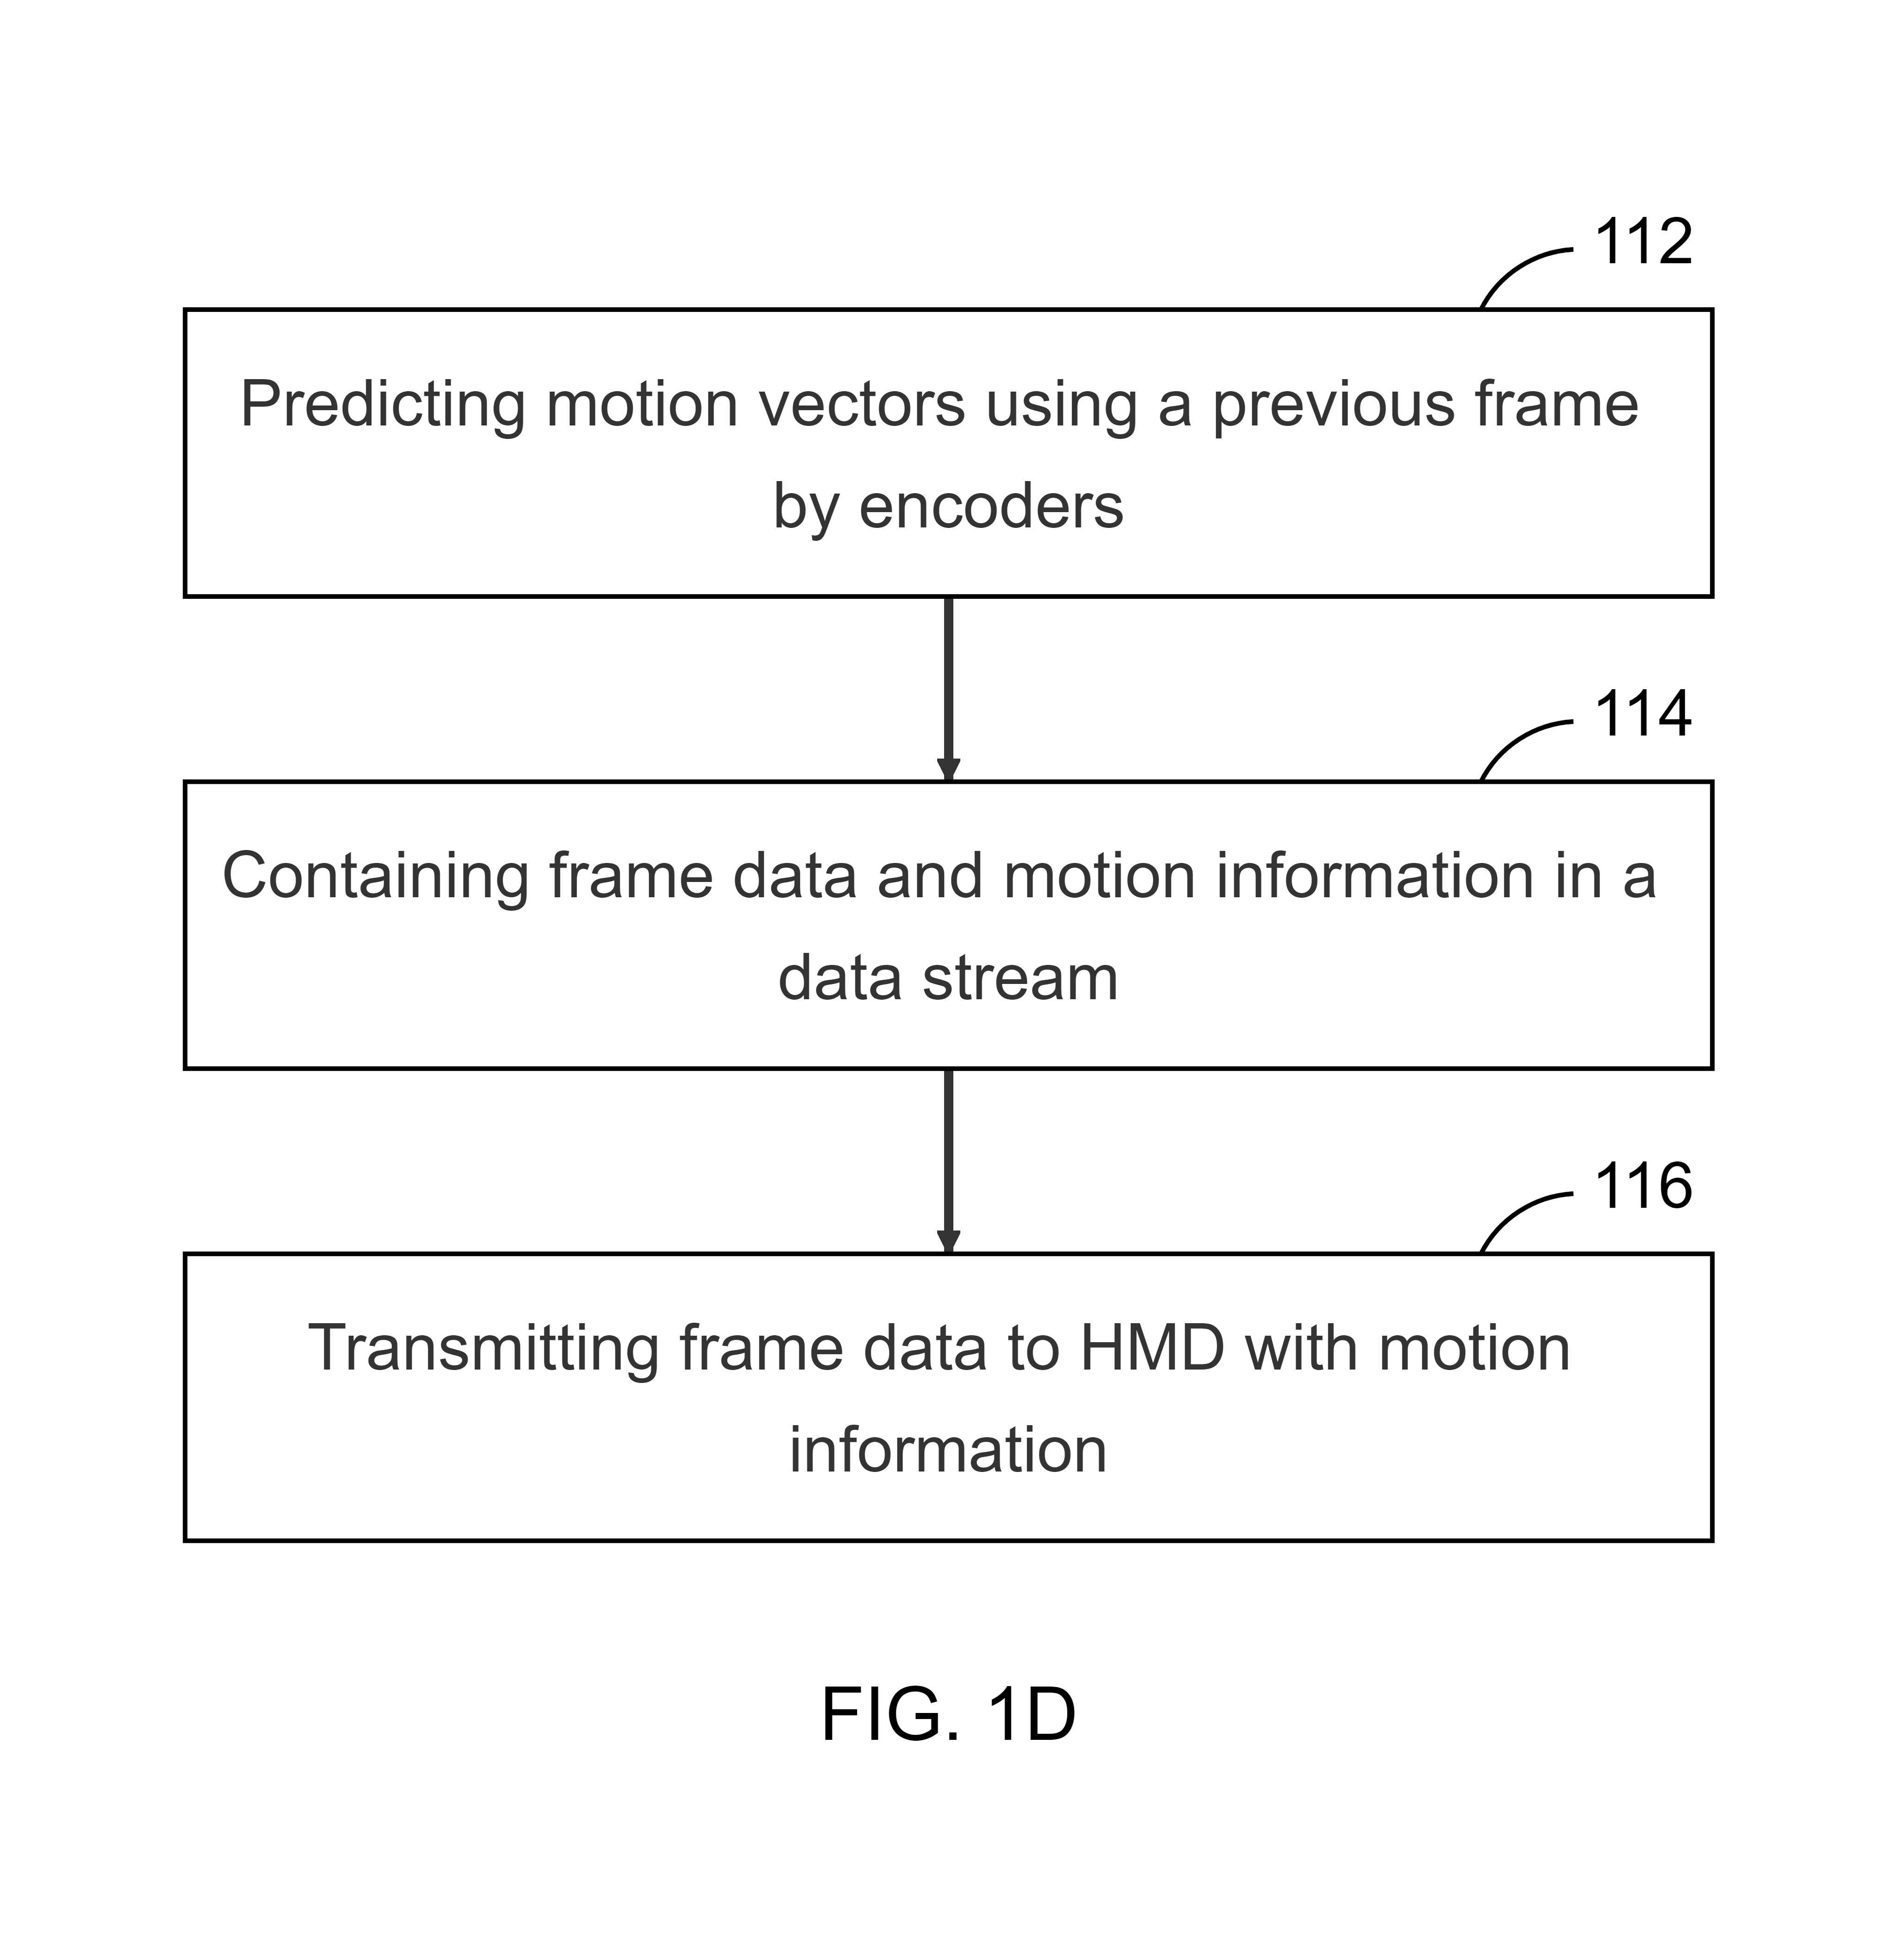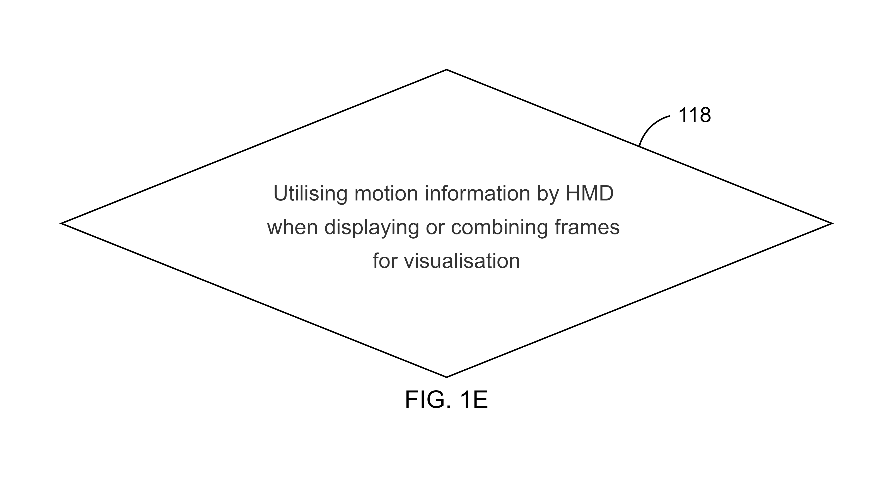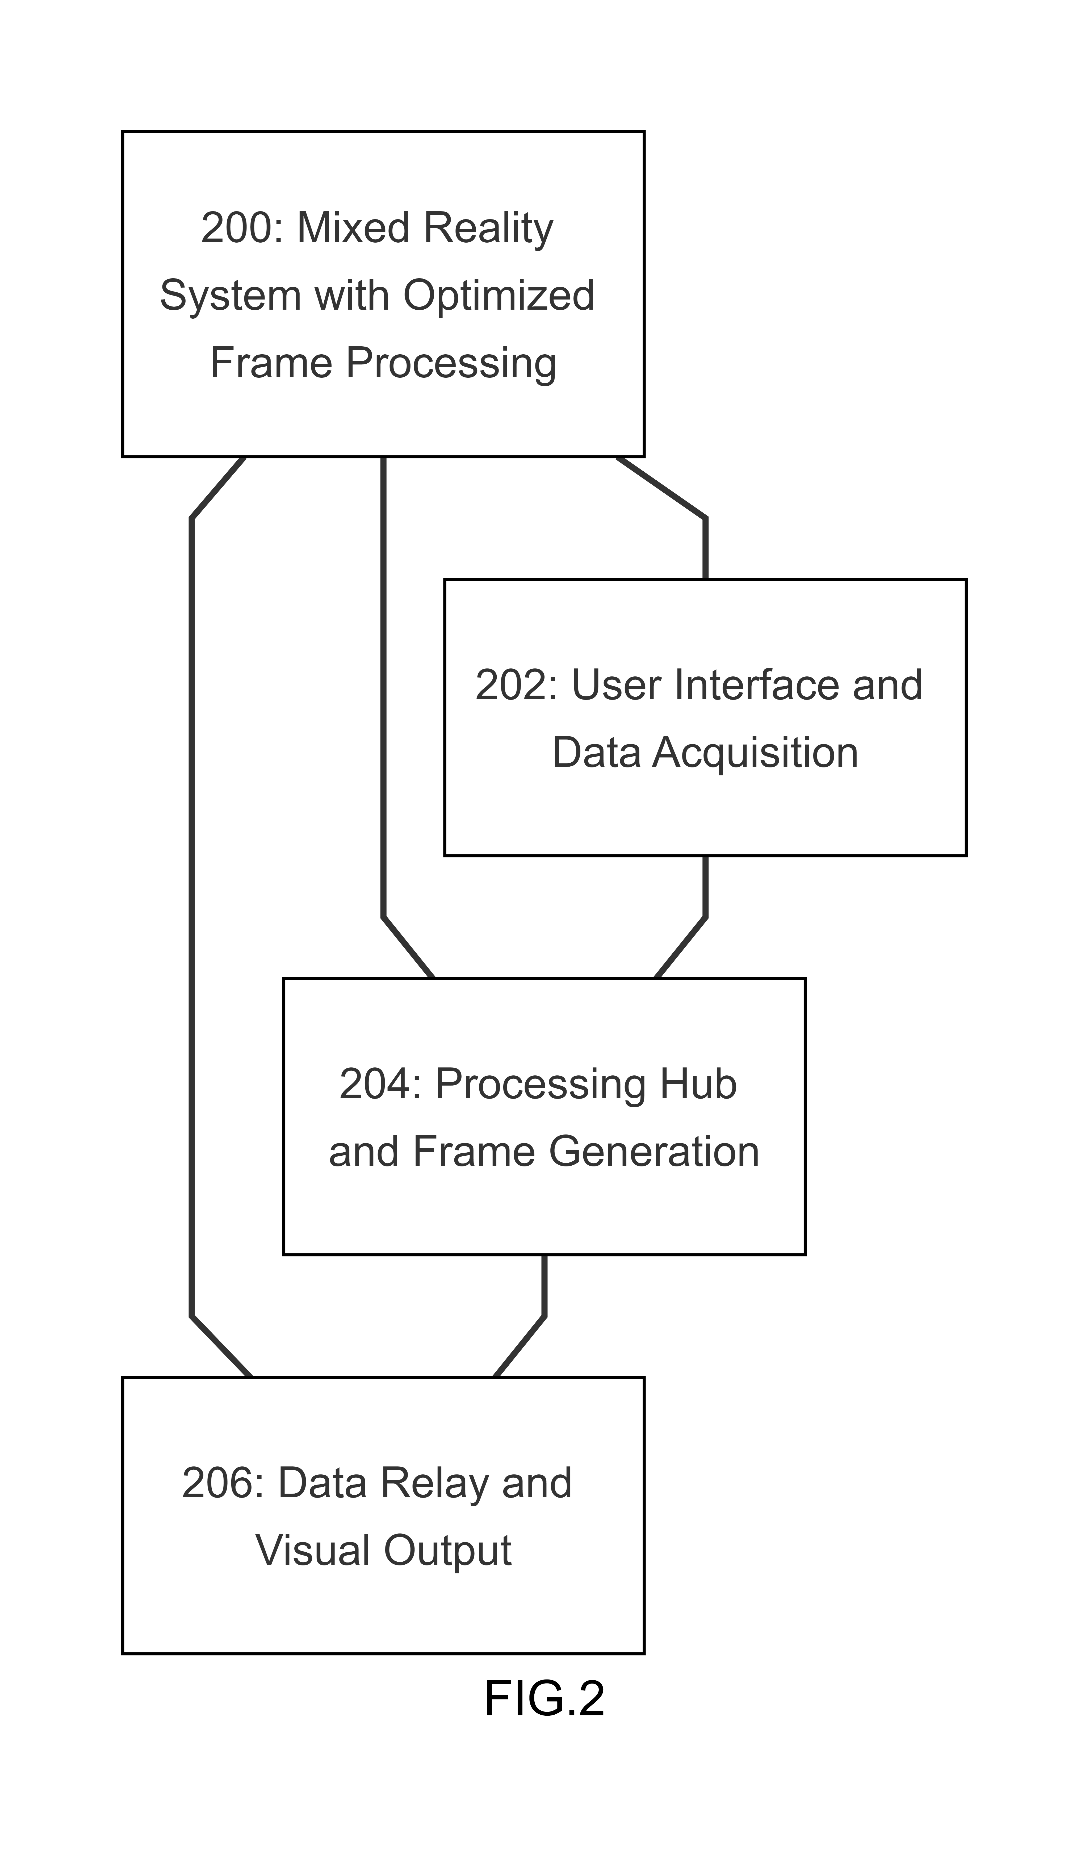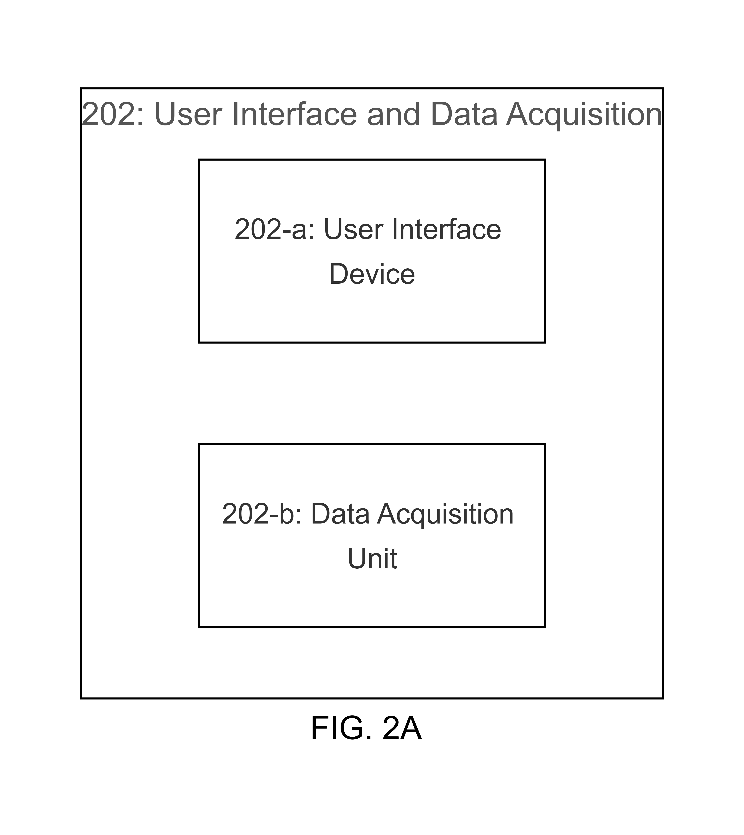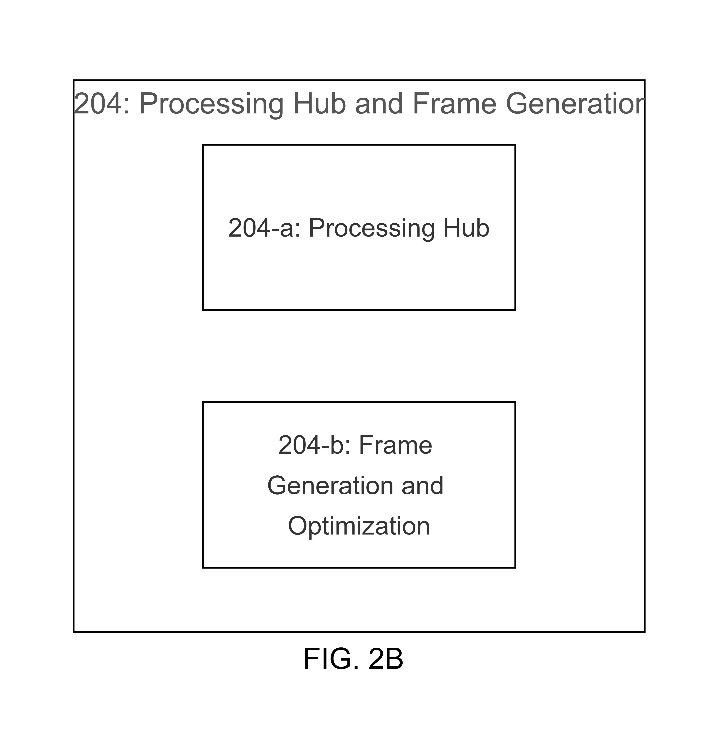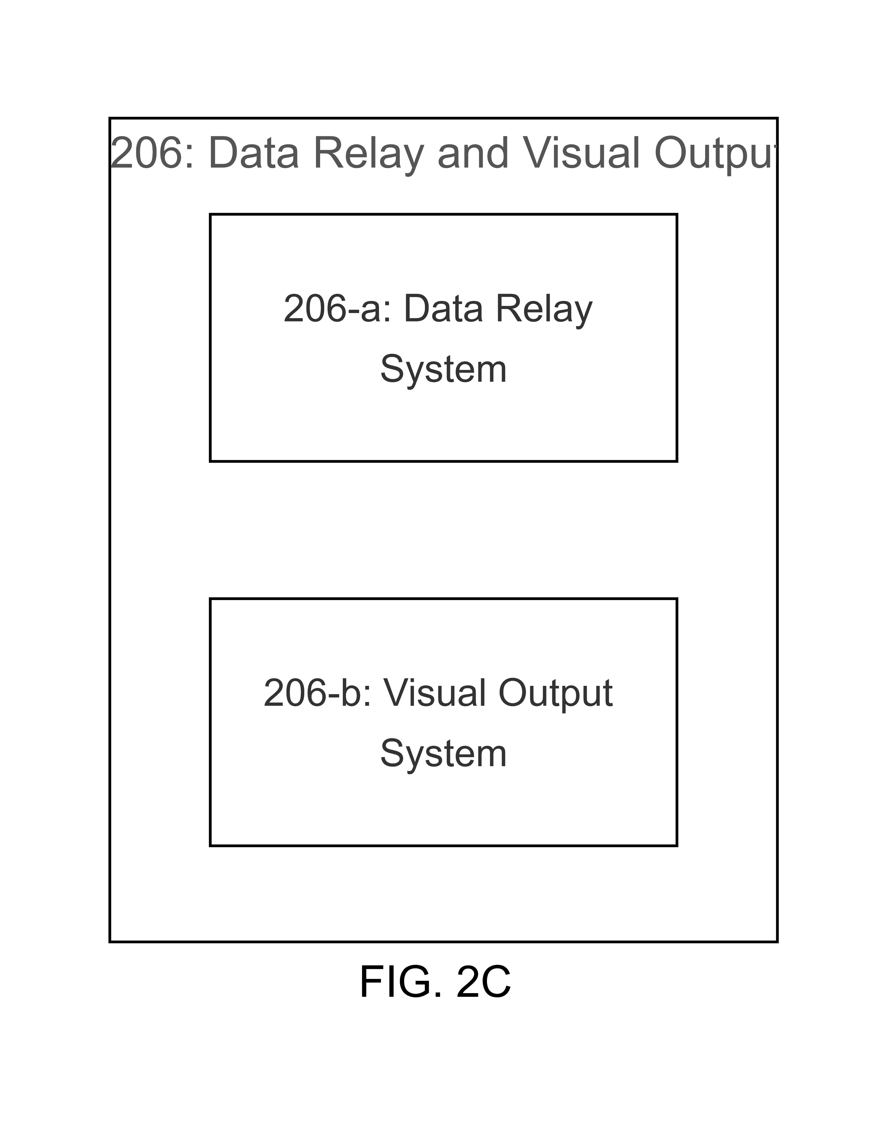
LIST OF FIGURES
FIG. 1 illustrates, in a flowchart, operations for processing and displaying virtual content in a mixed reality system in accordance with certain embodiments.
FIG. 1A illustrates, in a flowchart, operations for providing a head-mounted display (HMD) that gathers and sends data about the environment and the user in accordance with certain embodiments.
FIG. 1B illustrates, in a flowchart, operations for providing a base station that creates, displays, and processes frames with virtual content in accordance with certain embodiments.
FIG. 1C illustrates, in a flowchart, operations for calculating and recording motion vectors and data using the HMD's sensors and a rendering application in accordance with certain embodiments.
FIG. 1D illustrates, in a flowchart, operations for predicting motion vectors, containing frame data and motion information in a data stream, and transmitting this data to the HMD in accordance with certain embodiments.
FIG. 1E illustrates, in a flowchart, operations for utilising motion information by the HMD when displaying or combining frames for visualisation in accordance with certain embodiments.
FIG. 2 illustrates, in a block diagram, the main components of a mixed reality system in accordance with certain embodiments.
FIG. 2A illustrates, in a block diagram, the User Interface and Data Acquisition component of a mixed reality system in accordance with certain embodiments.
FIG. 2B illustrates, in a block diagram, the Processing Hub and Frame Generation component of a mixed reality system in accordance with certain embodiments.
FIG. 2C illustrates, in a block diagram, the Data Relay and Visual Output component of a mixed reality system in accordance with certain embodiments.

DETAILED DESCRIPTION
Step 100 involves the use of a head-mounted display (HMD) equipped with sensors designed to detect the environment and the user. The HMD collects data from these sensors and transmits it to a base station via a connection.
The HMD is a device worn on the head. It contains sensors that collect information about the surroundings and the user. The sensors that detect the environment gather data about physical objects, light conditions, spatial dimensions, among other things. The sensors that detect the user gather data about eye movements, facial expressions, head movements, among other things.
The HMD sends this data to a base station, a separate device that receives the data and uses it to create and display frames with virtual content. The connection between the HMD and the base station can be either wired or wireless.
This step sets up the initial configuration of the mixed reality system. By using a HMD that can detect the environment and the user, the system can create an immersive and interactive experience. The data collected by the HMD is used by the base station to generate accurate and relevant virtual content.
In this step, the HMD, the sensors that detect the environment and the user, and the base station are involved. The actions include the HMD collecting data, the sensors detecting the environment and the user, and the HMD transmitting the data to the base station.
Step 102 involves the use of a base station. This base station is configured to create frames with virtual content using data from sensors. It also processes frames using a method that utilises motion vectors.
The base station is a device that receives data from a head-mounted display (HMD). This data, collected by the HMD's sensors, includes information about the user and the environment. Using this data, the base station creates frames with virtual content and displays them.
In addition to creating and displaying frames, the base station also processes these frames. This process involves encoding, transmitting, and decoding the frames. To optimise this process, the base station uses motion vectors. These vectors are calculated from motion data recorded by the HMD's sensors and a rendering application on the base station.
In this step, the base station, the frames, the sensor data, the motion vectors, and the rendering application are involved. The actions include the base station creating and displaying frames, processing frames, and using motion vectors.
The base station creates frames with virtual content based on the sensor data. It then displays these frames. The base station also processes the frames, which involves encoding, transmitting, and decoding them. To optimise this process, the base station uses motion vectors. These vectors are calculated from motion data recorded by the HMD's sensors and a rendering application on the base station.
Step 104 involves the base station processing frames. This process includes encoding, transmitting, and decoding the frames.
The base station is a device that receives data from a head-mounted display (HMD). This data is used to create frames with virtual content. After these frames are created, they are processed before being displayed. This processing involves encoding the frames, transmitting them to the HMD, and then decoding them.
Encoding is the conversion of frame data into a format suitable for transmission. This includes compressing the data and adding error correction codes. The encoded frames are then transmitted to the HMD via a connection. Upon receipt, the HMD decodes the frames. Decoding is the conversion of the transmitted data back into its original format.
The base station uses motion vectors to optimise the time taken for processing. These vectors are calculated from motion data recorded by the HMD's sensors and a rendering application on the base station.
In this step, the base station, the frames, and the motion vectors are involved. The actions include the base station processing the frames and using motion vectors.
The base station processes the frames by encoding, transmitting, and decoding them. This involves converting the frame data into a transmittable format, sending the encoded frames to the HMD, and converting the transmitted data back into its original format. The base station uses motion vectors to optimise this process. The vectors are calculated from motion data recorded by the HMD's sensors and a rendering application on the base station.
Step 106 involves the calculation of motion vectors from motion data. This data is recorded by the sensors of a head-mounted display (HMD) and a rendering application on a base station.
Motion vectors are used to represent movement. They are derived from motion data, which is a record of changes in position over time. The motion data in this context is recorded by the sensors of the HMD and a rendering application on the base station.
The sensors of the HMD detect movement, which could include the movement of the user's head, eyes, or other body parts. This movement is recorded as motion data. The rendering application on the base station also records motion data, which could include the movement of virtual objects or points in the virtual content.
The motion vectors are derived from this motion data. This involves determining the direction and magnitude of the movement. The motion vectors are then used in the processing of frames by the base station. This could involve using the motion vectors to predict the position of objects or points in future frames, which can reduce the time taken to encode the frames.
In this step, the sensors of the HMD, the rendering application on the base station, the motion data, and the motion vectors are involved. The actions include the sensors of the HMD and the rendering application recording motion data, and the base station calculating motion vectors from this data.
The sensors of the HMD and the rendering application record motion data by detecting and tracking movement. The base station calculates motion vectors from this data by determining the direction and magnitude of the movement. The base station then uses these motion vectors in the processing of frames.
Step 108 involves the sensors of a head-mounted display (HMD) recording motion data.
The HMD is a device worn on the head, equipped with sensors designed to detect movement. These sensors can include accelerometers, gyroscopes, and other types of motion sensors. The sensors detect movement by measuring changes in position, orientation, and velocity over time.
The sensors record this movement as motion data. This data is a record of changes in position, orientation, and velocity over time. The motion data is then used by a base station to calculate motion vectors, which are used in the processing of frames.
In this step, the sensors of the HMD and the motion data are involved. The action involves the sensors of the HMD recording motion data.
The sensors of the HMD record motion data by detecting and tracking movement. This involves measuring changes in position, orientation, and velocity over time. The sensors then convert these measurements into a digital format that can be processed by the base station. The motion data is used by the base station to calculate motion vectors, which are used in the processing of frames.
Step 110 involves a rendering application calculating motion vectors for virtual content.
A rendering application is a software program that generates images from models. In this context, the rendering application creates virtual content for a mixed reality system. The virtual content consists of frames, which are individual images displayed in sequence to create the perception of movement.
The rendering application calculates motion vectors for the virtual content. Motion vectors represent movement and are derived from motion data, which is a record of changes in position over time. The motion data is recorded by the sensors of a head-mounted display (HMD) and the rendering application.
The motion vectors are used in the processing of frames by a base station. This could involve using the motion vectors to predict the position of objects or points in future frames, which can reduce the time taken to encode the frames.
In this step, the rendering application, the virtual content, the motion data, and the motion vectors are involved. The action involves the rendering application calculating motion vectors for the virtual content.
The rendering application calculates motion vectors for the virtual content by analysing the motion data. This involves determining the direction and magnitude of the movement of objects or points in the virtual content. The rendering application then uses these motion vectors in the processing of frames by the base station.
Step 112 involves encoders predicting motion vectors using a previous frame.
Encoders are devices or software that convert data from one format to another. In this context, the encoders process frames in a mixed reality system. The frames are individual images displayed in sequence to create the perception of movement.
The encoders predict motion vectors using a previous frame. Motion vectors represent movement and are derived from motion data, which is a record of changes in position over time. The motion data in this context is recorded by the sensors of a head-mounted display (HMD) and a rendering application on a base station.
The prediction of motion vectors using a previous frame allows the encoders to optimise the processing of frames. This could involve using the motion vectors to predict the position of objects or points in future frames, which can reduce the time taken to encode the frames.
In this step, the encoders, the frames, the motion data, and the motion vectors are involved. The action involves the encoders predicting motion vectors using a previous frame.
The encoders predict motion vectors using a previous frame by analysing the motion data. This involves determining the direction and magnitude of the movement of objects or points in the previous frame. The encoders then use these motion vectors in the processing of frames.
Step 114 involves a data stream containing frame data and motion information.
A data stream is a sequence of digitally encoded signals used to transmit or receive information. In this context, the data stream transmits information from a base station to a head-mounted display (HMD) in a mixed reality system.
The data stream contains frame data and motion information. Frame data is a digital representation of frames, which are individual images displayed in sequence to create the perception of movement. Motion information is a record of changes in position over time. This could include the movement of the user's head, eyes, or other body parts, as well as the movement of virtual objects or points in the virtual content.
The base station embeds the frame data and motion information in the data stream. This involves encoding the frame data and motion information into a transmittable format, and then inserting this encoded data into the data stream. The data stream is then transmitted to the HMD, where it is decoded and used to display the frames and track movement.
In this step, the data stream, the frame data, and the motion information are involved. The action involves the base station embedding the frame data and motion information in the data stream.
The base station embeds the frame data and motion information in the data stream by encoding the data into a transmittable format, and then inserting this encoded data into the data stream. The data stream is then transmitted to the HMD, where it is decoded and used to display frames and track movement.
Step 116 involves the transmission of frame data to a head-mounted display (HMD) along with motion information.
Transmission of data involves sending it from one location to another. In this context, data is sent from a base station to a HMD in a mixed reality system. The data transmitted includes frame data and motion information.
Frame data is a digital representation of frames, which are individual images displayed in sequence to create the perception of movement. Motion information is a record of changes in position over time. This could include the movement of the user's head, eyes, or other body parts, as well as the movement of virtual objects or points in the virtual content.
The base station transmits the frame data to the HMD along with the motion information. This involves encoding the frame data and motion information into a transmittable format, inserting this encoded data into a data stream, and sending this data stream to the HMD. The HMD receives the data stream, decodes the frame data and motion information, and uses this data to display the frames and track movement.
In this step, the base station, the HMD, the frame data, and the motion information are involved. The action involves the base station transmitting the frame data and motion information to the HMD.
The base station transmits the frame data and motion information to the HMD by encoding the data into a transmittable format, inserting this encoded data into a data stream, and sending this data stream to the HMD. The HMD receives the data stream, decodes the frame data and motion information, and uses this data to display frames and track movement.
Step 118 involves a head-mounted display (HMD) using motion information when displaying or combining frames for visualisation.
A HMD is a device worn on the head that provides a display in front of one or both eyes. In this context, the HMD displays frames in a mixed reality system. The frames are individual images displayed in sequence to create the perception of movement.
The HMD uses motion information when displaying or combining frames. Motion information is a record of changes in position over time. This could include the movement of the user's head, eyes, or other body parts, as well as the movement of virtual objects or points in the virtual content.
The HMD adjusts the display of the frames using the motion information. This could involve changing the position, orientation, or size of the frames based on the user's movement. The HMD could also use the motion information to combine multiple frames into a single frame, creating the perception of smooth movement.
In this step, the HMD, the frames, and the motion information are involved. The action involves the HMD using motion information when displaying or combining frames.
The HMD uses motion information when displaying or combining frames by adjusting the display based on the motion information. This involves changing the position, orientation, or size of the frames based on the user's movement. The HMD could also use the motion information to combine multiple frames into a single frame, creating the perception of smooth movement.
Step 120 involves a head-mounted display (HMD) that includes world-facing and user-facing sensors.
A HMD is a device worn on the head that provides a display in front of one or both eyes. In this context, the HMD displays frames in a mixed reality system. The frames are individual images displayed in sequence to create the perception of movement.
The HMD includes world-facing and user-facing sensors. World-facing sensors detect the environment around the user. This could include physical objects, light conditions, spatial dimensions, and more. User-facing sensors detect the user. This could include the user's eye movements, facial expressions, head movements, and more.
The sensors collect data about the environment and the user. This data is then used by a base station to create and display frames with virtual content. The inclusion of these sensors in the HMD allows the mixed reality system to provide an experience that is responsive to the user's environment and actions.
In this step, the HMD, the world-facing sensors, and the user-facing sensors are involved. The action involves the HMD including world-facing and user-facing sensors.
The HMD includes world-facing and user-facing sensors in its design. The sensors collect data about the environment and the user by detecting physical objects, light conditions, spatial dimensions, eye movements, facial expressions, head movements, and more. This data is then used by the base station to create and display frames with virtual content.
Step 122 involves a base station generating and rendering frames with virtual content based on sensor data.
A base station is a device that receives data from a head-mounted display (HMD) and uses this data to create and display frames with virtual content. The frames are individual images displayed in sequence to create the perception of movement. Virtual content refers to digital objects and environments displayed in the frames.
The base station generates and renders frames with virtual content using sensor data. The sensor data is collected by the HMD's sensors and includes information about the user and the environment. This could include the user's eye movements, facial expressions, head movements, and more, as well as data about physical objects, light conditions, spatial dimensions, and more in the environment.
The base station uses the sensor data to generate virtual content that corresponds to the user's environment and interactions. This involves creating digital objects and environments based on the physical objects and conditions detected by the sensors. The base station then renders the frames with the virtual content. Rendering involves converting the digital objects and environments into a format that can be displayed on the HMD.
In this step, the base station, the frames, the virtual content, and the sensor data are involved. The action involves the base station generating and rendering frames with virtual content using sensor data.
The base station generates and renders frames with virtual content using sensor data by creating digital objects and environments based on the physical objects and conditions detected by the sensors, and then converting these digital objects and environments into a format that can be displayed on the HMD.
Step 124 involves an encoding method that reduces the time to encode rendered frames by using motion vectors. These vectors are determined from motion data captured by the sensors of a head-mounted display (HMD) and motion vectors for virtual content determined by a rendering application on a base station.
Encoding is a process that converts data from one format to another. In this context, the encoding method processes frames in a mixed reality system. The frames are individual images displayed in sequence to create the perception of movement.
The encoding method uses motion vectors to reduce the time to encode the rendered frames. Motion vectors represent movement and are derived from motion data, which is a record of changes in position over time. The motion data in this context is captured by the sensors of the HMD and the motion vectors for virtual content are determined by the rendering application on the base station.
The use of motion vectors allows the encoding method to predict the position of objects or points in future frames, reducing the time to encode the frames. This can enhance the performance of the mixed reality system by enabling quicker and smoother display of frames.
In this step, the encoding method, the frames, the motion vectors, the motion data, the sensors of the HMD, and the rendering application are involved. The action involves the encoding method using motion vectors to reduce the time to encode the rendered frames.
The encoding method uses motion vectors determined from motion data captured by the sensors of the HMD and motion vectors for virtual content determined by the rendering application on the base station. This involves predicting the position of objects or points in future frames based on the motion vectors, reducing the time to encode the frames.
Step 126 involves the encoder on a base station embedding motion information in the data stream sent to a head-mounted display (HMD) along with the frame data.
An encoder is a device or software that converts data from one format to another. In this context, the encoder processes frames in a mixed reality system. The frames are individual images displayed in sequence to create the perception of movement.
The encoder on the base station uses motion information when processing frames. Motion information is a record of changes in position over time. This could include the movement of the user's head, eyes, or other body parts, as well as the movement of virtual objects or points in the virtual content.
The motion information used by the encoder is embedded in the data stream sent to the HMD along with the frame data. This involves encoding the motion information into a transmittable format, and then inserting this encoded motion information into the data stream. The data stream is then transmitted to the HMD, where it is decoded and used to display the frames and track movement.
In this step, the encoder, the base station, the data stream, the frame data, and the motion information are involved. The action involves the encoder on the base station embedding the motion information in the data stream sent to the HMD along with the frame data.
The encoder on the base station embeds the motion information in the data stream sent to the HMD along with the frame data by encoding the motion information into a transmittable format, and then inserting this encoded motion information into the data stream. The data stream is then transmitted to the HMD, where it is decoded and used to display frames and track movement.
Step 128 involves a head-mounted display (HMD) synthesizing a frame if a current frame is not received from a base station.
A HMD is a device worn on the head that provides a display in front of one or both eyes. In this context, the HMD displays frames in a mixed reality system. The frames are individual images displayed in sequence to create the perception of movement.
The HMD synthesizes a frame if a current frame is not received from the base station. This could occur if there is a delay or interruption in the transmission of the data stream from the base station to the HMD. In such cases, the HMD uses motion information and the previous frame to synthesize a new frame.
The synthesis of a frame involves creating a new image that predicts what the current frame would have been if it had been received. This prediction is based on the motion information, which is a record of changes in position over time, and the previous frame, which is the last frame received from the base station.
In this step, the HMD, the frames, and the motion information are involved. The action involves the HMD synthesizing a frame if a current frame is not received from the base station.
The HMD synthesizes a frame if a current frame is not received from the base station by creating a new image that predicts what the current frame would have been if it had been received. This prediction is based on the motion information and the previous frame. The synthesized frame is then displayed, providing a continuous visual experience despite the delay or interruption in the transmission of the data stream.
Step 130 involves a head-mounted display (HMD) communicating with a base station via a connection.
A HMD is a device worn on the head that provides a display in front of one or both eyes. In this context, the HMD displays frames in a mixed reality system. The frames are individual images displayed in sequence to create the perception of movement.
The HMD communicates with the base station via a connection. This involves transmitting data from the HMD to the base station and receiving data from the base station. The data transmitted and received includes frame data and motion information.
The connection allows the HMD and the base station to exchange data in real time. This enables the base station to create and display frames with virtual content based on the sensor data from the HMD, and the HMD to display the frames and track the movement of objects or points based on the motion information from the base station.
In this step, the HMD, the base station, and the connection are involved. The action involves the HMD communicating with the base station via a connection.
The HMD communicates with the base station via a connection by transmitting and receiving data. This involves sending frame data and motion information from the HMD to the base station, and receiving frame data and motion information from the base station. The connection allows the HMD and the base station to exchange data in real time, enabling the creation and display of frames with virtual content and the tracking of movement.
Step 132 involves a base station using an encoding method that uses motion vectors to reduce the time taken to encode frames.
An encoding method is a process that converts data from one format to another. In this context, the encoding method processes frames in a mixed reality system. The frames are individual images displayed in sequence to create the perception of movement.
The base station uses an encoding method that uses motion vectors. Motion vectors represent movement and are derived from motion data, which is a record of changes in position over time. The motion data in this context is recorded by the sensors of a head-mounted display (HMD) and a rendering application on the base station.
The use of motion vectors allows the encoding method to predict the position of objects or points in future frames, reducing the time taken to encode the frames. This can enhance the performance of the mixed reality system by enabling quicker and smoother display of frames.
In this step, the base station, the encoding method, the frames, and the motion vectors are involved. The action involves the base station using an encoding method that uses motion vectors.
The base station uses an encoding method that uses motion vectors by predicting the position of objects or points in future frames based on the motion vectors. This involves calculating the motion vectors from the motion data, and then using these motion vectors to predict the position of objects or points in future frames. The predicted positions are then used to encode the frames, reducing the time taken to encode the frames.
Step 134 involves determining motion vectors from motion data captured by the sensors of a head-mounted display (HMD) and by a rendering application on a base station.
Motion vectors represent movement and are derived from motion data, which is a record of changes in position over time. The motion data in this context is captured by the sensors of the HMD and a rendering application on the base station.
The sensors of the HMD detect movement, which could include the movement of the user's head, eyes, or other body parts. The sensors record this movement as motion data. The rendering application on the base station also records motion data, which could include the movement of virtual objects or points in the virtual content.
The motion vectors are determined from this motion data. This involves calculating the direction and magnitude of the movement. The motion vectors are then used in the processing of frames by the base station. This could involve using the motion vectors to predict the position of objects or points in future frames, reducing the time taken to encode the frames.
In this step, the sensors of the HMD, the rendering application, the motion data, and the motion vectors are involved. The action involves determining motion vectors from motion data captured by the sensors of the HMD and by a rendering application on the base station.
The motion vectors are determined from motion data captured by the sensors of the HMD and by a rendering application on the base station by calculating the direction and magnitude of the movement. The motion vectors are then used in the processing of frames by the base station, which could involve predicting the position of objects or points in future frames, reducing the time taken to encode the frames.
Scenario 1: Consider a situation where a user is wearing the HMD and is in a virtual environment where they are interacting with virtual objects. As the user moves their head or eyes, the sensors on the HMD capture this motion data. Simultaneously, the rendering application on the base station is also recording motion data of the virtual objects in the virtual content. Both sets of motion data are used to calculate motion vectors. These motion vectors are then used in the processing of frames by the base station, specifically in predicting the position of objects or points in future frames. This reduces the time taken to encode the frames, allowing for a smoother and more responsive virtual experience for the user.
Scenario 2: In another situation, the user might be in a mixed reality environment where they are interacting with both real and virtual objects. As the user moves around in the real world, the sensors on the HMD capture this motion data. At the same time, the rendering application on the base station is recording motion data of the virtual objects. The motion vectors calculated from this motion data are used by the base station to optimise the processing of frames. This involves predicting the position of the virtual objects in future frames based on the user's movements in the real world, allowing for a seamless integration of the real and virtual environments.
Component 200 refers to a system that includes a head-mounted display (HMD) and a base station. The HMD has sensors that detect the environment and the user. These sensors collect data about the surroundings and the user's movements. This data is then sent to the base station through a connection, which can be either wired or wireless.
Sub-component 202-a, Sensor Data Gathering, involves the HMD's sensors capturing data about the surroundings, including physical objects, lighting conditions, and spatial dimensions. At the same time, the sensors that detect the user track movements, facial expressions, and eye movements. This dual data collection allows the system to understand the user's interaction with the surroundings.
Sub-component 202-b, Data Relay, involves the HMD sending the collected data to the base station. This transmission can occur over a wired or wireless connection, depending on the specific setup of the system. The base station receives this data and uses it to generate virtual content that responds to the user's environment and actions.
The system's goal is to create a mixed reality experience. By gathering and transmitting real-time data, the system can generate virtual content that reflects and responds to the user's environment and movements. This process allows for interactivity and immersion in the mixed reality environment.
Component 202 refers to a part of the system that includes a head-mounted display (HMD) and its role in collecting and sending data. The HMD has sensors that detect the environment and the user. These sensors collect data, which is then sent to the base station.
Sub-component 202-a, Sensor Data Gathering, involves the HMD's sensors capturing data about the surroundings and the user. The sensors that detect the environment collect data about physical objects, lighting conditions, and spatial dimensions in the surroundings. The sensors that detect the user track movements, facial expressions, and eye movements. This dual data collection provides an understanding of the user's interaction with the surroundings.
Sub-component 202-b, Data Relay, involves the HMD sending the collected data to the base station. The transmission can occur over a wired or wireless connection, depending on the specific setup of the system. The base station receives this data and uses it to generate virtual content that responds to the user's environment and actions.
The goal of this component is to collect and send real-time data about the user's environment and movements. This data is used to generate virtual content that reflects and responds to the user's environment and movements, allowing for interactivity and immersion in the mixed reality environment. The data collection and transmission processes are continuous and occur as long as the system is in operation.
Component 204 refers to a part of the system that includes a base station and its role in creating and displaying frames with virtual content. The base station uses the data received from the HMD to generate frames.
Sub-component 204-a, Virtual Frame Generation, involves the base station creating frames with virtual content. The base station uses the sensor data received from the HMD to generate these frames. The content in the frames is created based on the data about the user's environment and actions, as captured by the HMD's sensors.
Sub-component 204-b, Frame Visualization, involves the HMD displaying the frames created by the base station. The HMD receives the frames from the base station and displays them to the user. The frames include content that is overlaid on the user's view, creating a mixed reality experience.
The goal of this component is to create and display frames with content that reflects and responds to the user's environment and actions. This is achieved by using data from the HMD's sensors to generate relevant content, and then displaying this content to the user. The frame creation and display processes are continuous and occur as long as the system is in operation.
Component 206 refers to a part of the system that includes a base station and its role in processing frames. The base station uses motion vectors to process the frames.
Sub-component 206-a, Efficient Frame Encoding, involves the base station encoding the frames. The base station uses motion vectors calculated from motion data recorded by the HMD's sensors and by a rendering application on the base station to encode the frames. This method reduces the time it takes to encode the frames compared to methods that estimate motion vectors using a previous frame.
Sub-component 206-b, Frame Data Transmission, involves the base station transmitting the encoded frames to the HMD. The base station embeds the frame data and motion information in a data stream and sends it to the HMD.
Sub-component 206-c, Frame Decoding and Rendering, involves the HMD decoding the received frames and rendering them for display. The HMD uses the motion information embedded in the data stream to decode the frames. If a frame is not received from the base station, the HMD can synthesise a frame using the motion information.
The goal of this component is to process and transmit frames with content that reflects and responds to the user's environment and actions. This is achieved by using motion vectors to optimise the encoding process, transmitting the encoded frames along with motion information to the HMD, and decoding and rendering the frames for display. The frame processing and transmission processes are continuous and occur as long as the system is in operation.
Scenario 1: A user is navigating a virtual museum tour using the mixed reality system. The HMD's sensors capture the user's movements as they turn their head to look at different exhibits. This motion data is encoded by the base station using motion vectors and transmitted back to the HMD. The HMD decodes this data and renders a new frame showing the exhibit the user is looking at, providing a seamless virtual tour experience.
Scenario 2: A user is playing a mixed reality game where they have to dodge virtual obstacles. The HMD's sensors record the user's movements as they dodge and weave. The base station encodes this motion data and transmits it back to the HMD. If there's a delay in transmission and the HMD doesn't receive the current frame in time, it uses the motion information to synthesise a new frame, ensuring the game continues without interruption.

CLAIMS
1. A mixed reality system, comprising:
a head-mounted display (HMD) including environment-detecting sensors and user-detecting sensors, said HMD configured to gather data about the environment and the user and send this data to a base station via a connection;
a base station configured to create and display frames with virtual content using the sensor data and process frames using a method that optimises time by utilising motion vectors;
wherein said frames are processed by the base station;
wherein motion vectors are calculated from motion data recorded by HMD's sensors and by a rendering application on the base station;
wherein motion data is recorded by HMD's sensors;
wherein a rendering application calculates motion vectors for virtual content;
wherein encoders predict motion vectors using a previous frame;
wherein a data stream contains frame data and motion information;
wherein frame data is transmitted to HMD with motion information;
wherein motion information is utilised by HMD when displaying or combining frames for visualisation.
2. A method for operating a mixed reality system, the method comprising:
providing a head-mounted display (HMD) including environment-detecting sensors and user-detecting sensors, said HMD configured to gather data about the environment and the user and send this data to a base station via a connection;
providing a base station configured to create and display frames with virtual content using the sensor data and process frames using a method that optimises time by utilising motion vectors;
processing said frames by the base station;
calculating motion vectors from motion data recorded by HMD's sensors and by a rendering application on the base station;
recording motion data by HMD's sensors;
calculating motion vectors for virtual content by a rendering application;
predicting motion vectors using a previous frame by encoders;
containing frame data and motion information in a data stream;
transmitting frame data to HMD with motion information;
utilising motion information by HMD when displaying or combining frames for visualisation.
3. The mixed reality system of claim 1, wherein the HMD includes world-facing and user-facing sensors.
4. The mixed reality system of claim 1, wherein the base station generates and renders frames with virtual content based on sensor data.
5. The mixed reality system of claim 1, wherein the encoding method reduces the time it takes to encode the rendered frames by using motion vectors determined from motion data captured by the HMD's sensors and motion vectors for virtual content determined by the rendering application on the base station.
6. The mixed reality system of claim 1, wherein the motion information used by the encoder on the base station is embedded in the data stream sent to the HMD along with the frame data.
7. The mixed reality system of claim 1, wherein the HMD synthesizes a frame if a current frame is not received from the base station.
8. The method of claim 2, wherein the HMD includes world-facing and user-facing sensors.
9. The method of claim 2, wherein the base station generates and renders frames with virtual content based on sensor data.
10. The method of claim 2, wherein the encoding method reduces the time it takes to encode the rendered frames by using motion vectors determined from motion data captured by the HMD's sensors and motion vectors for virtual content determined by the rendering application on the base station.
11. The method of claim 2, wherein the motion information used by the encoder on the base station is embedded in the data stream sent to the HMD along with the frame data.
12. The method of claim 2, wherein the HMD synthesizes a frame if a current frame is not received from the base station.
13. The mixed reality system of claim 3, wherein the HMD communicates with the base station via a wired or wireless connection.
14. The mixed reality system of claim 4, wherein the base station uses an encoding method that reduces time by using motion vectors.
15. The mixed reality system of claim 5, wherein the motion vectors are determined from motion data captured by the HMD's sensors and by a rendering application on the base station.
16. The mixed reality system of claim 6, wherein the data stream includes frame data and motion information.
17. The mixed reality system of claim 7, wherein the motion information is used by the HMD when rendering or compositing frames for display.
18. The method of claim 8, wherein the HMD communicates with the base station via a wired or wireless connection.
19. The method of claim 9, wherein the base station uses an encoding method that reduces time by using motion vectors.
20. The method of claim 10, wherein the motion vectors are determined from motion data captured by the HMD's sensors and by a rendering application on the base station.

